DIGITAL PRODUCT MANAGEMENT

CIA 1

Sahasaarathi: A Unified Platform for Government Information and Services

Product Management Report
Submitted
By
Amey Tiwari
25221004
Table of Contents
1. Introduction 3
2. Minutes of the Meeting 3
3. Scope and Key Decisions 4
3.1 Interpreting the brief 4
3.2 Layered design and pilot city 4
3.3 Modules 4
3.4 Depth of service 4
3.5 Data principle 5
3.6 Summary of decisions 5
4. Challenges 6
4.1 Challenges for citizens 6
4.2 Challenges for government staff 7
4.3 System constraints 7
5. Product Opportunities 7
5.1 Value summary 8
6. User Research and Personas 9
6.1 Approach 9
6.2 Public side personas 9
6.3 Government side personas 10
7. Goals and Features 10
7.1 Product goals 10
7.2 Public side features 11
7.3 Government side features 12
7.4 Out of scope and future scope 12
8. Wireframe 13
8.1 Design approach 13
8.2 Public side walkthrough 14
8.3 Government side walkthrough 17
8.4 How the two sides connect 20
9. Iteration and Analysis 20
9.1 Concept iterations 20
9.2 Wireframe version 1 to version 2 21
9.3 Review of version 2 and planned version 3 changes 22
10. Assumptions, Risks and Open Questions 23
10.1 Assumptions 23
10.2 Risks and mitigations 23
11. Conclusion 24
Annexure A: Prompt Sheet 25

1. Introduction
Sahasaarathi (working name) is a unified platform that gives citizens verified answers about public infrastructure and government-owned information, and gives government staff one place to keep that information accurate and to handle grievances. It has two sides: a public side for citizens and a government side for municipal and state staff. The pilot covers Delhi-NCR.
Government information today sits across many digital portals, paper records and individual offices. A citizen who wants to know which police station covers their home, where to report a broken streetlight, or which taxes they owe must work out the right authority and portal alone. The product removes that burden. It answers from one verified source, names the responsible office, and lets the citizen act inside the app.

2. Minutes of the Meeting
Date and time | 22 October 2026, 10:45 am
Participants | Client (faculty member) and the student product manager
Parties represented | Government servants (the client) and the general public
Focus | Solve the information flow for government digital infrastructure
Budget | INR 5 lakh, for the entire project end to end (not only the wireframe)
Requirement | An app that answers the general FAQs people have about public infrastructure (physical or digital) and government-owned information. It should have a government (municipal or state) side and a public side.
Examples given | Which local thana or jurisdiction a home belongs to  Information on police personnel  How to register grievances and where, since government digital infrastructure is fragmented  Which different taxes people can or have to pay
Next step | Prepare questions for the next discussion

The next meeting with the client takes place after this submission. The questions I prepared are therefore recorded as open questions in Section 10, and the decisions that depended on them are stated as assumptions.

3. Scope and Key Decisions

3.1 Interpreting the brief
The meeting notes state the focus as the information flow for government digital infrastructure, while the examples (thana jurisdiction, police personnel, taxes) cover physical offices and institutions as well. Two readings were possible. The narrow reading treats the product as a guide to government portals and digital services. The broad reading treats it as an answer to the wider question, who do I go to, and how, across offices, police, taxes and portals.
I chose the broad reading with a digital-first core. The reason is awareness. Many people do not know that a service or portal exists at all, so the problem begins before they reach the wrong portal. Digital portals stay central because that is where people get lost, and physical offices appear as the fallback answer.

3.2 Layered design and pilot city
The product has two layers. The central layer covers services that are the same everywhere in the country and needs no location. The local layer covers jurisdiction, police stations, municipal grievances and local taxes, and is built fully for one pilot city. If a user is outside the pilot, the product shows the central layer and a clear message that their city is not live yet.
The pilot city is Delhi-NCR. Delhi, Uttar Pradesh and Haryana authorities sit side by side there, so a single home can fall under confusing overlapping jurisdictions. That makes the fragmentation problem visible and the examples concrete. The mechanism, address in and responsible authority out, is the same in any city, so scaling means adding one more city of content rather than rebuilding the product.

3.3 Modules
Three modules share one engine. The base is a Who covers me? jurisdiction finder that takes an address and returns the police station, municipal zone and key offices. On top of it sit a grievances module (where to file, how, and how to track) and a taxes and dues module (which taxes apply, who collects them, and where to pay). Utilities, certificates and transport are left as future scope.

3.4 Depth of service
From a customer journey point of view, the citizen should not have to leave the app. Because government portals differ in how far they cooperate, the product uses three tiers.
Tier | What the citizen experiences | How it works | When used
1. File in the app | A short pre-filled form inside the app, then a reference number | The app forwards the complaint to the department inbox on the government side, by email or by an interface where one exists | Departments that join the platform
2. Portal inside the app | The official portal opens in an in-app window with a way back to the answer card | An in-app browser view, with details pre-filled where the portal allows | Departments with a portal that will not integrate
3. Link out with help | The portal opens outside the app, with the office address and phone as a fallback | A standard link | Last resort, for portals that block embedding or are down

3.5 Data principle
Only officially published, public information is shown. No personal data is exposed. For police, this means station details and published contact information only. Every answer shows its source and the date it was last verified.

3.6 Summary of decisions
Decision | Choice | Rationale
Reading of the brief | Broad, with a digital-first core | The problem starts with low awareness of services, not only with portals
Architecture | Central layer plus a local layer per city | Combines concreteness with reach
Pilot city | Delhi-NCR | Overlapping authorities make the problem visible
Modules | Who covers me?, grievances, taxes and dues | Named in the brief, frequent, and hurt by fragmentation
Depth | Three tiers of in-app filing | Keeps the citizen in the app and gives the government side a real inbox
Data | Public, officially published only | Protects privacy and builds trust

4. Challenges
The challenges below come from the client brief, the meeting, and my own mapping of the journey a citizen follows today. An earlier exploratory civic action decision tree, from a personal side project, showed how many decisions a citizen must make before reaching the right office: the type of issue, the level of government, whether a portal exists, how to follow up, and what to do if nothing happens. Only the grievance and information branches of that work informed this product.

4.1 Challenges for citizens
ID | Challenge | Why it matters
C1 | Information is fragmented across portals, paper records and individual offices | Citizens cannot tell which source is complete or current
C2 | Low awareness: many people do not know that a service or portal exists | The problem begins before search, so a better search box alone does not fix it
C3 | Jurisdiction confusion: a home can fall under overlapping authorities (police station, municipal zone, state boundaries in Delhi-NCR) | Reports go to the wrong office or are delayed
C4 | Trust: it is hard to tell an official site from an unofficial one | Risk of misinformation or fraud, and hesitation to act
C5 | Language and digital literacy: portals are often English-heavy and complex | First-time and older users are excluded
C6 | No visibility after action: after filing, citizens get little status or follow-up guidance | Loss of confidence, repeat visits and repeat complaints

4.2 Challenges for government staff
ID | Challenge | Why it matters
G1 | Information is held in registers, PDFs and several portals, and updating is manual | Entries go stale
G2 | Repeat queries at the counter on the same offices, forms and fees | Staff time is consumed by questions that could be self-served
G3 | No single queue for grievances across channels | Items get lost or delayed
G4 | Misrouted grievances need manual reassignment | Delay and unclear ownership
G5 | It is unclear who verified what, and when | Public trust in the information erodes

4.3 System constraints
ID | Constraint | Implication for the design
S1 | Budget of INR 5 lakh for the whole project, end to end | Favours routing and verified content over deep integration with every department
S2 | Portals may block embedding, need their own login, or change often | The design cannot rely on every portal cooperating, hence the three tiers
S3 | Information must be public and officially published | No personal data, and police information limited to published details
S4 | Deliverables are a wireframe and a short demo | The scope must be small enough to show a few flows convincingly

Taken together, the central challenge is that the information exists but cannot be found, trusted or acted on from one place, and the people who maintain it have no efficient way to keep it current.

5. Product Opportunities
Each opportunity below answers one or more of the challenges in Section 4 and points to the screens where the response is visible in the wireframe. Screen numbers 01 to 09 are public screens and G1 to G6 are government screens.
ID | Addresses | Opportunity | Product response | Screens
O1 | C1, G1 | One verified source of truth | Departments publish an entry once, and citizens read from the same record | 01, 04, G2, G3
O2 | C2 | Surface services people do not know about | Four entry points and common questions on the home screen | 01
O3 | C3 | Address-based routing | The citizen enters a location and the product names the police station, zone office and key offices | 02, 04, 07
O4 | C4, G5 | Trust through provenance | Every answer shows its source and last verified date, backed by a verification and approval flow | 04, G3, G4
O5 | C5 | Inclusive access | English and Hindi toggle, plain labels, large tiles, Call and Directions buttons | 01, 07
O6 | C6 | Close the loop after action | In-app filing, reference number, expected timeline, tracking and escalation | 05, 06, 09, G5
O7 | G2 | Reduce repeat queries | Self-service answers, and a most-asked view that shows which entries to improve | 04, G2
O8 | G3, G4 | One queue and correct routing | A grievance inbox with status updates and routing rules that map area and issue to office | G5, G6
O9 | S1, S2 | Lean and scalable | Layered design and tiered filing, so adding a city or a department means adding content | 02

5.1 Value summary
- For citizens: a faster and more confident path from a question to the right office, without leaving the app.
- For government staff: fewer repeat queries, information that stays current, and one grievance queue.
- For the institution: demand data on what citizens ask most, which shows where information is missing or unclear.

6. User Research and Personas

6.1 Approach
As specified for this assignment, user research is presented through user personas. The personas are assumption-based. They are built from the client brief, the meeting, the earlier journey mapping, and general knowledge of how citizens and municipal staff use these services. Names, ages and quotes are illustrative. Validation with real users is a recommended next step.

6.2 Public side personas
Persona 1 | Ritu Sharma, 34, marketing manager
Context | Rents a flat in Lajpat Nagar, Delhi, and moved there two months ago. Comfortable with apps, short on time, and uses her phone for most things.
Goals | Know which police station and municipal office cover her new home, report civic issues quickly, and know which taxes apply to her.
Pain points | Information is scattered across portals, she cannot tell which is official, and she hears nothing after filing a complaint.
Needs from the product | Address-based answers, filing without leaving the app, status tracking, and the source shown on every answer.
Illustrative quote | I just want to know who to tell, and whether anyone is acting on it.
Key screens | 01, 02, 03, 04, 05, 06, 07, 09

Persona 2 | Ramesh Yadav, 58, retired shopkeeper
Context | Long-time resident of the same area. Hindi-first, uses a basic smartphone, and often asks his son for help with anything official.
Goals | Know where to go in person, what to bring, and what he owes.
Pain points | Portals are in English, he cannot tell genuine websites from fake ones, and offices send him from one counter to another.
Needs from the product | Hindi toggle, large tiles, plain answers of the form go here and bring this, and an office address with Call and Directions buttons.
Illustrative quote | Just tell me which office, and when it is open.
Key screens | 01, 04, 07

6.3 Government side personas
Persona 3 | Anita Verma, 41, nodal officer, municipal zone office
Context | Works at a desk on a desktop browser, has moderate digital comfort, and handles the same questions repeatedly at the counter.
Goals | Keep information accurate with minimal effort, reduce repeat queries, and handle grievances without losing track.
Pain points | Information sits in registers and PDFs, updates take effort, and she has no single view of pending complaints.
Needs from the product | A simple entry form, flags for stale entries, an approval flow, and one grievance inbox.
Key screens | G1, G2, G3, G5

Persona 4 (secondary) | Mr. Khan, 52, supervisor
Context | Approves what goes public and is answerable for its accuracy.
Needs from the product | A side-by-side view of proposed changes, a version history, and a view of overdue grievances.
Key screens | G4, G5

7. Goals and Features

7.1 Product goals
Side | Goal | Indicative target
Public | A citizen finds the right authority and next step quickly and acts without leaving the app | Right office found in under one minute
Government | Keep verified information current with minimal effort and handle grievances in one queue | Every entry re-verified within 90 days, with older entries flagged on the dashboard
Shared | Every answer can be trusted and traced | Source and last verified date shown on every answer
Grievances | Citizens know what happens after they file | Reference number and expected timeline on every report (7 working days in the example)
The targets are indicative assumptions for design purposes. They are not measured values.

7.2 Public side features
Priority | Feature | Screen
Must have | Home with search and four entry points | 01
Must have | English and Hindi toggle | 01
Must have | Location entry and a city not live yet fallback | 02
Must have | Issue categories | 03
Must have | Answer card with source and last verified date | 04
Must have | In-app grievance form, pre-filled | 05
Must have | Confirmation with reference number | 06
Must have | Who covers me? with Call and Directions | 07
Must have | Taxes and dues guide with in-app payment view | 08
Must have | Track report with OTP login | 09
Should have | Follow-up and escalation reminders | 09
Should have | Find a service (the central layer) | Entry point only in version 2
Should have | Saved addresses | Not shown
Later | Voice search, more departments and cities, other transactions | Not shown

7.3 Government side features
Priority | Feature | Screen
Must have | Role-based sign-in | G1
Must have | Dashboard with stale and pending flags | G2
Must have | Edit entry with version history | G3
Must have | Supervisor approval flow | G4
Must have | Grievance inbox with status updates | G5
Must have | Routing rules that map area and issue type to an office | G6
Should have | Overdue flags and most-asked queries | G2, G5
Later | Full analytics, integration with department systems, other departments | Not shown

7.4 Out of scope and future scope
- Direct payment and other transactions inside the product.
- Departments beyond police, municipal services and taxes.
- Cities beyond the Delhi-NCR pilot.
- Deep integration with department back-end systems.
- Voice search and offline mode.

8. Wireframe

8.1 Design approach
The wireframe was designed in Figma as a low-fidelity, grayscale design with rounded cards, simple icons and plain labels. The public side is designed for mobile at 390 by 844 pixels and the government side for desktop at 1440 by 900 pixels. All data is example data, and no live government records are used. Each answer shows its source and last verified date, and each screen shows its position in the flow.
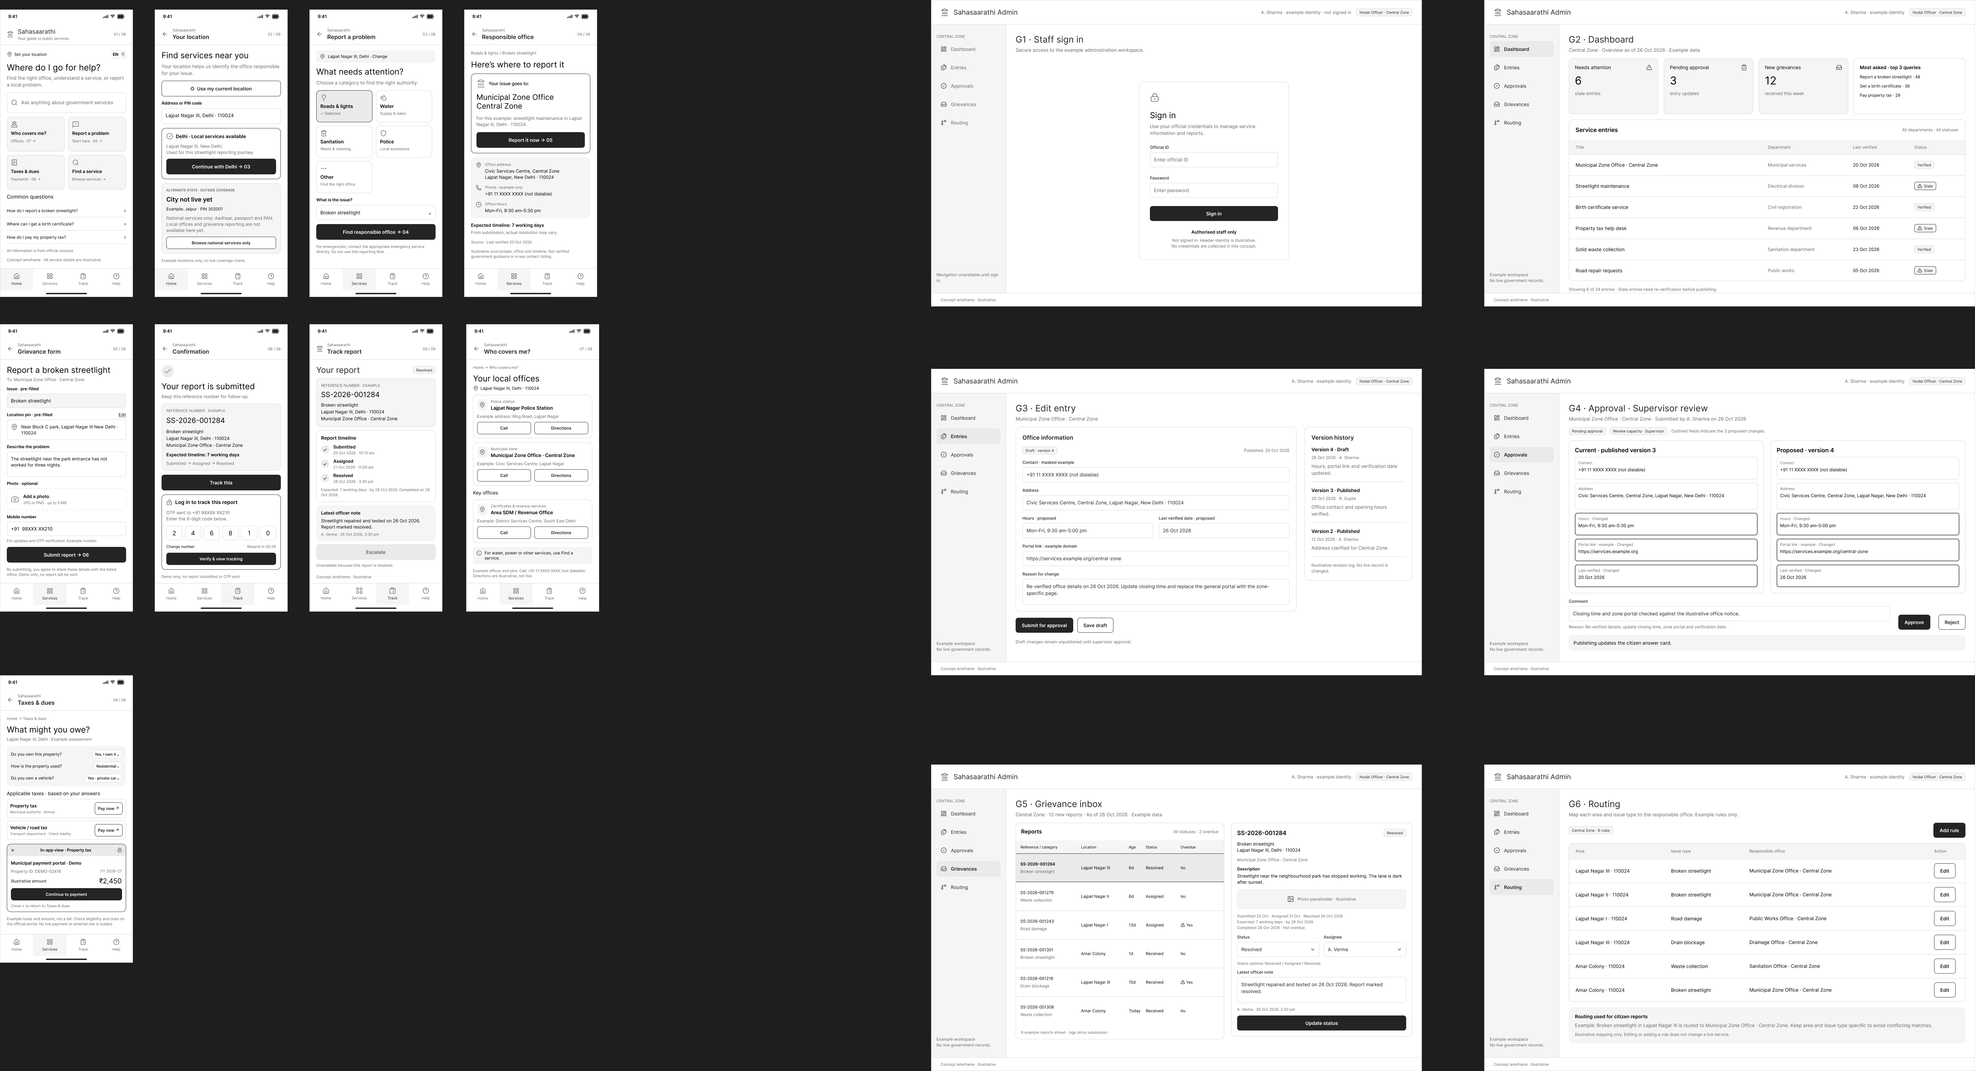
Figure 2: Overview of wireframe version 2 (9 public screens and 6 government screens)

8.2 Public side walkthrough
A citizen, Ritu, wants to report a broken streetlight near her home. She starts at the home screen, sets her location, picks the issue, sees which office is responsible, files the report in the app, and later tracks it.
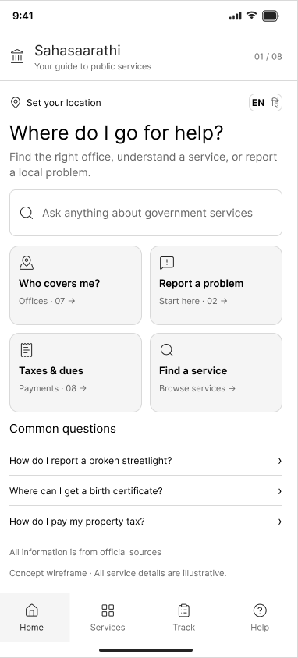  Screen 01: Home | 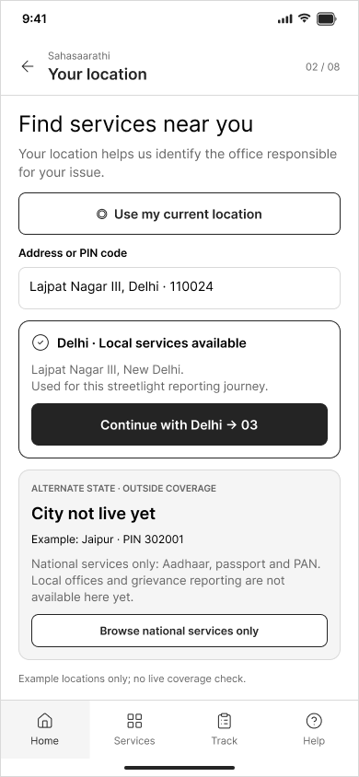  Screen 02: Your location | 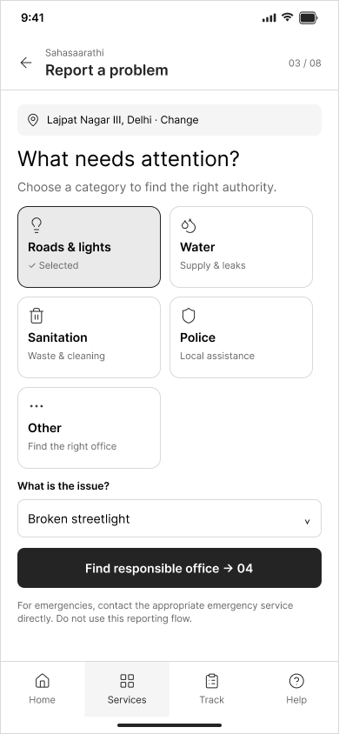  Screen 03: Report a problem
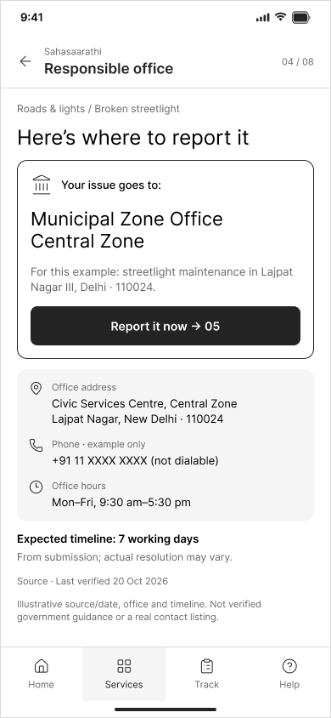  Screen 04: Responsible office | 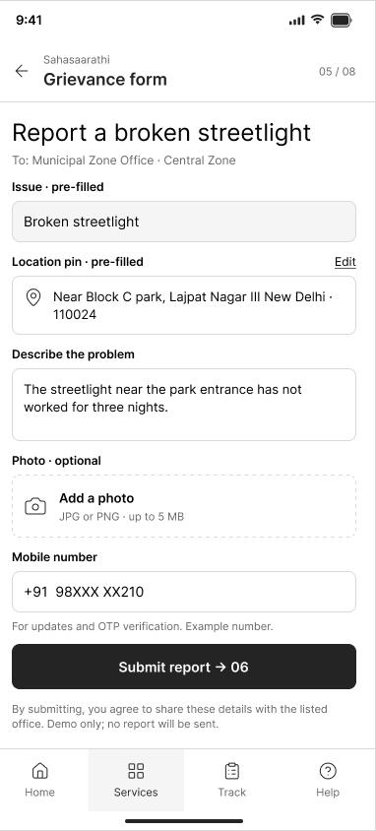  Screen 05: Grievance form | 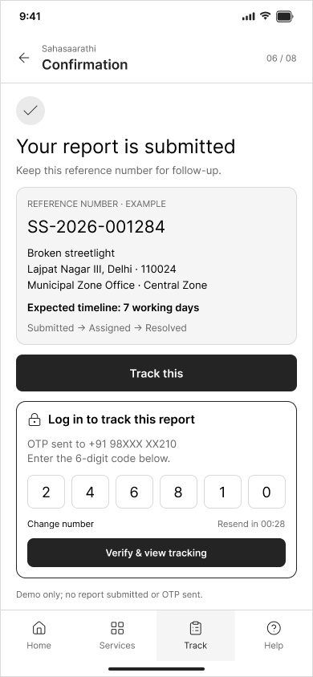  Screen 06: Confirmation
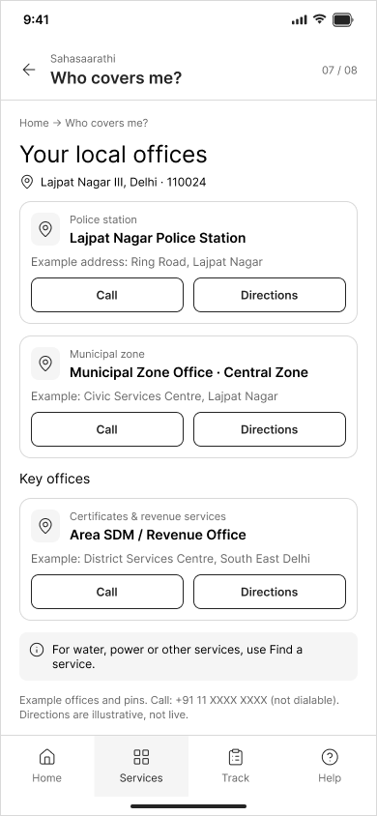  Screen 07: Who covers me? | 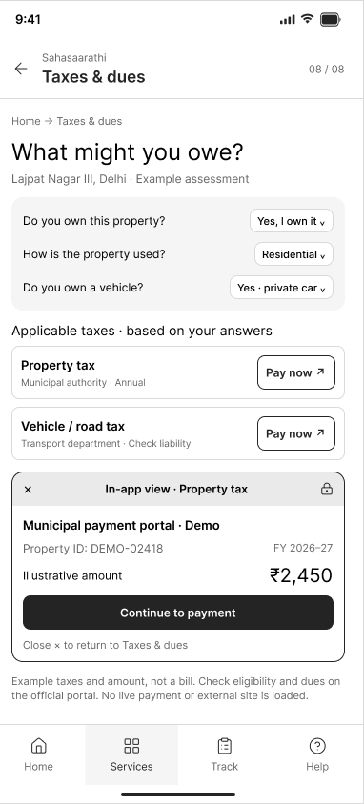  Screen 08: Taxes and dues | 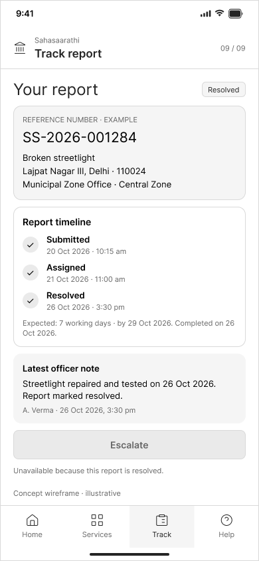  Screen 09: Track report
Figure 3: Public side screens 01 to 09
Screen | Purpose | Key elements | Addresses
01 Home | Orient the citizen and offer four entry points | Search bar, EN and Hindi toggle, four tiles, common questions, note that all information is from official sources | C2, C5
02 Your location | Set the location to unlock local services, with a fallback for uncovered cities | Use my current location, address or PIN field, Delhi local services card, City not live yet state with national services only | C1, C3
03 Report a problem | Choose the issue category | Icon grid (roads and lights, water, sanitation, police, other), issue dropdown, emergency note | C2
04 Responsible office | Name the office that handles the issue | Your issue goes to card, Report it now button, office address, phone and hours, expected timeline, source and last verified date | C1, C3, C4
05 Grievance form | File the report inside the app | Pre-filled issue and location pin, description, optional photo, mobile number, Submit report | C6
06 Confirmation | Confirm submission and offer tracking | Reference number, expected timeline, Track this button, OTP login | C6
07 Who covers me? | Show the authorities for an address | Police station, municipal zone and key offices, each with Call and Directions | C3, C5
08 Taxes and dues | Explain which taxes apply and allow payment | Guided questions, applicable taxes list, Pay now, in-app payment view | C1, C2
09 Track report | Show status after filing | Reference number, timeline, latest officer note, Escalate button | C6

8.3 Government side walkthrough
A nodal officer, Anita, keeps entries current and handles grievances, and a supervisor reviews changes before they go public. The government side is designed for desktop and shares the visual style of the public side.
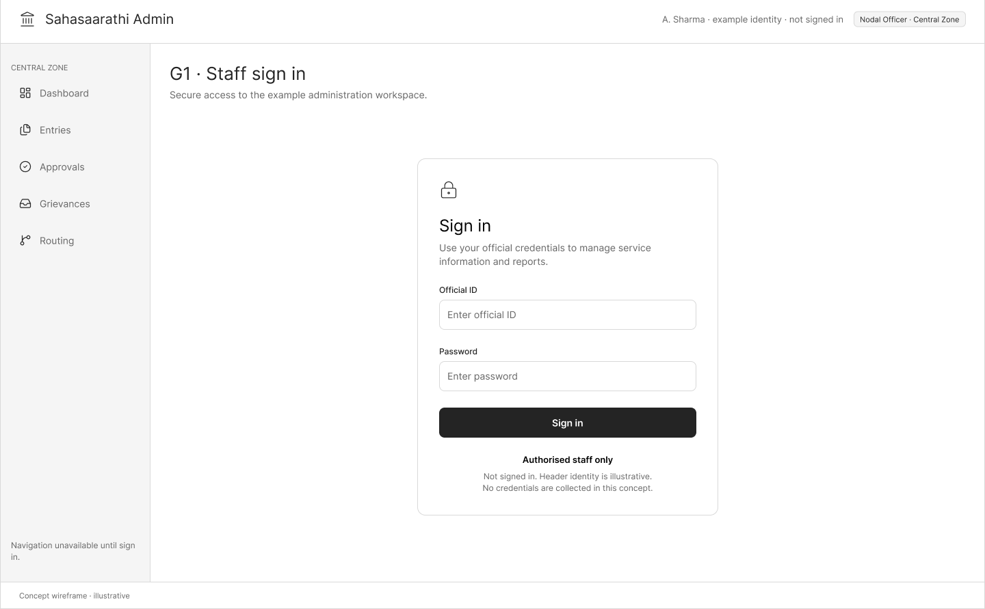
Screen G1: Staff sign in
Secure entry for authorised staff, using an official ID and password. The role, nodal officer or supervisor, is applied after sign-in.
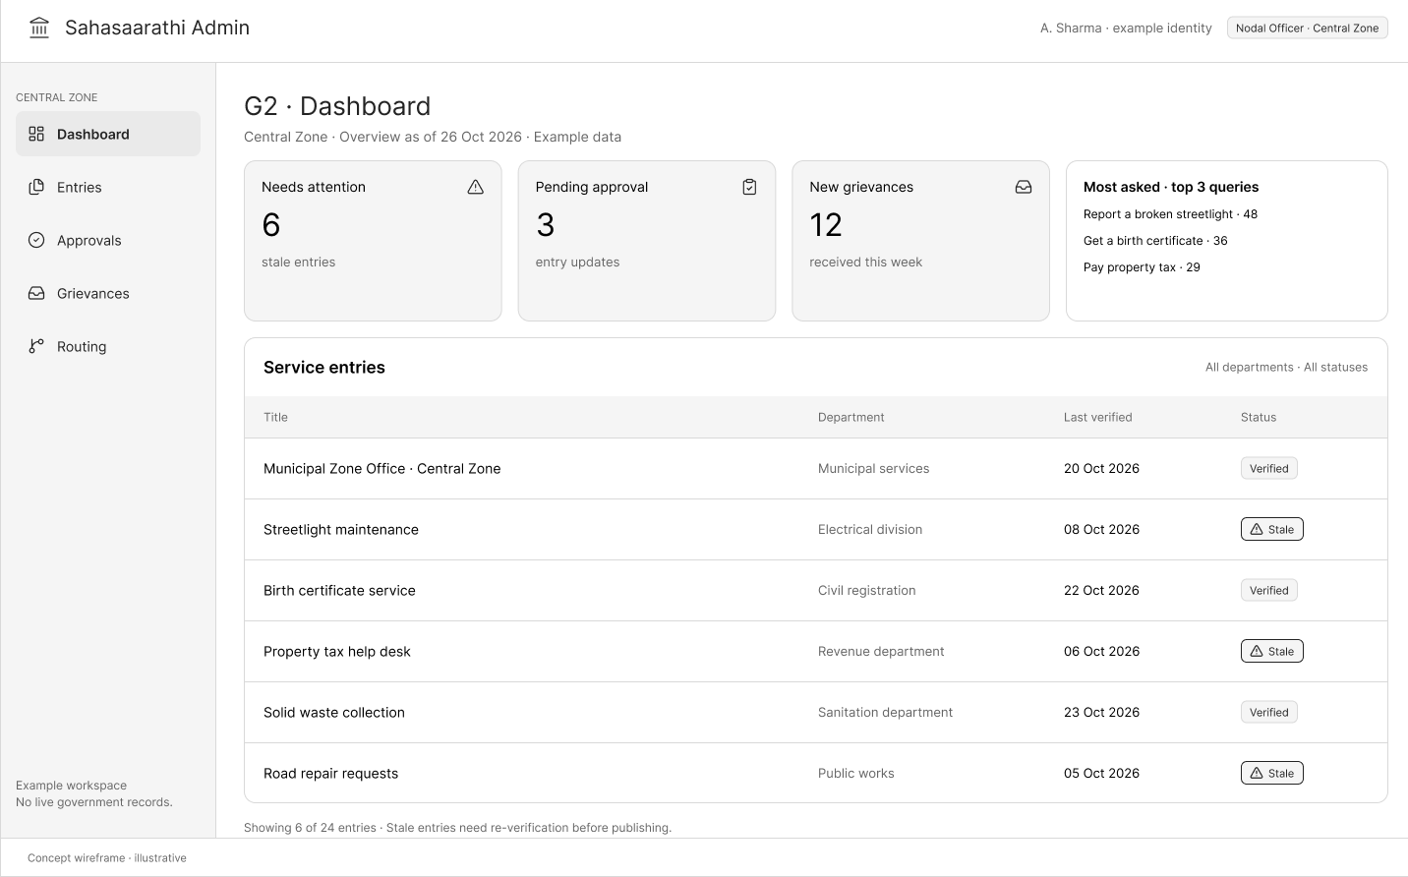
Screen G2: Dashboard
Four cards (needs attention, pending approval, new grievances, most asked queries) above a table of service entries with last verified date and a Verified or Stale tag.
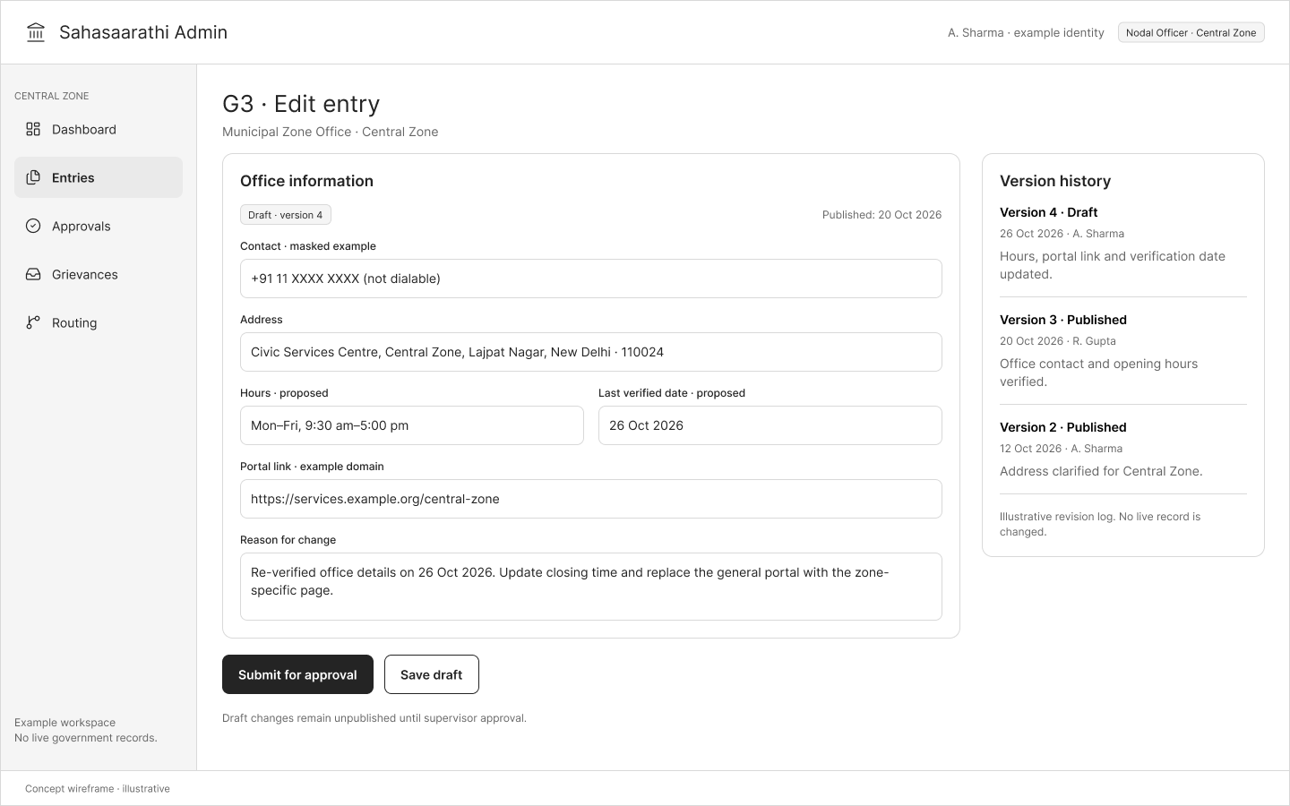
Screen G3: Edit entry
A form for contact, address, hours, portal link, last verified date and reason for change, with Submit for approval, Save draft and a version history panel.
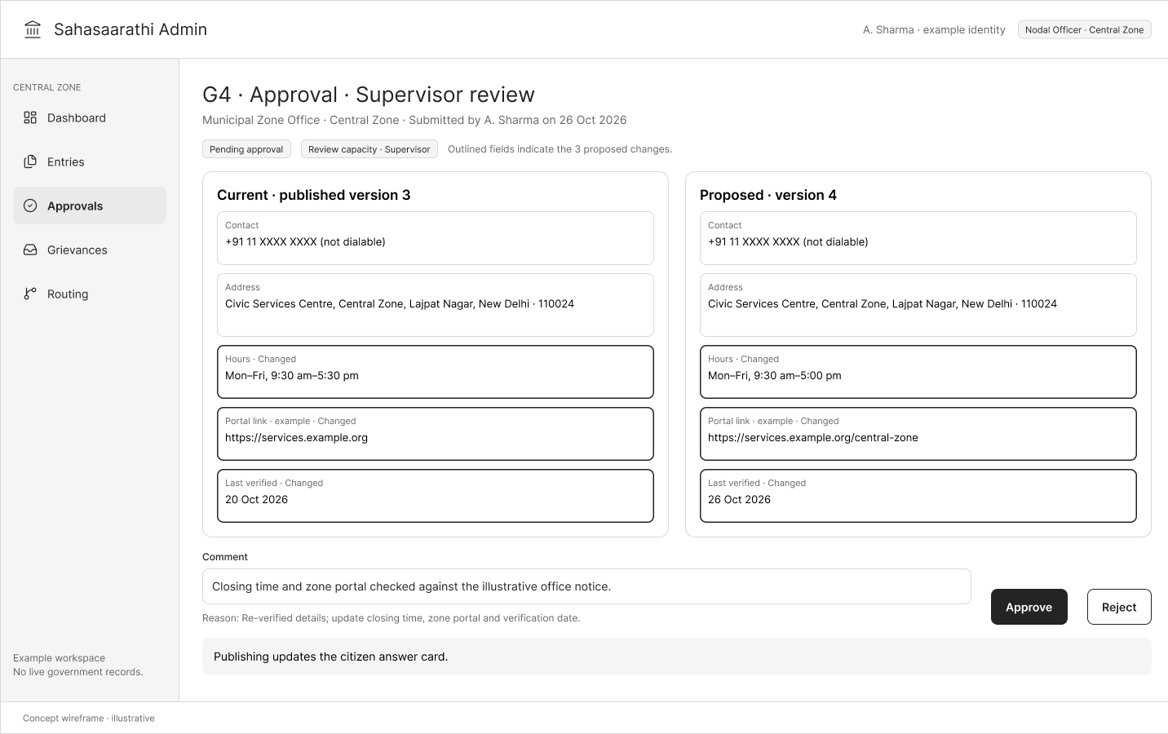
Screen G4: Approval
The supervisor sees the published version beside the proposed version, with changed fields outlined, and can approve or reject with a comment. Publishing updates the citizen answer card.
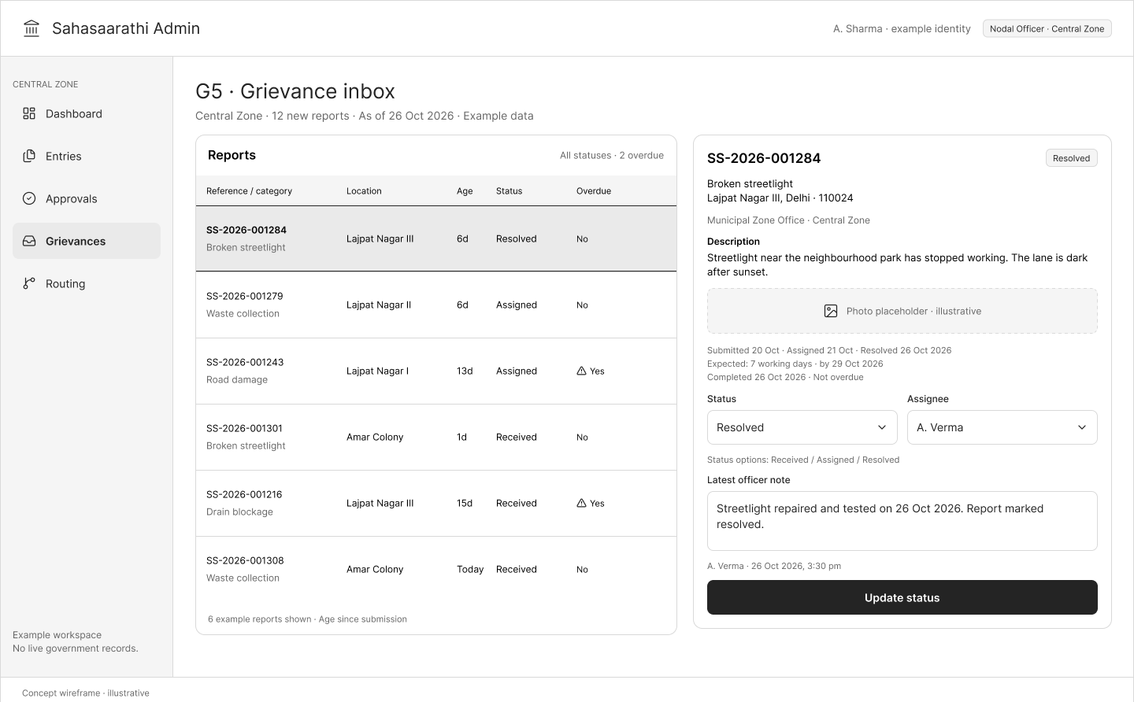
Screen G5: Grievance inbox
A list of reports with reference, category, location, age, status and an overdue flag, and a detail panel to change status, assign an officer and add a note that the citizen can see.
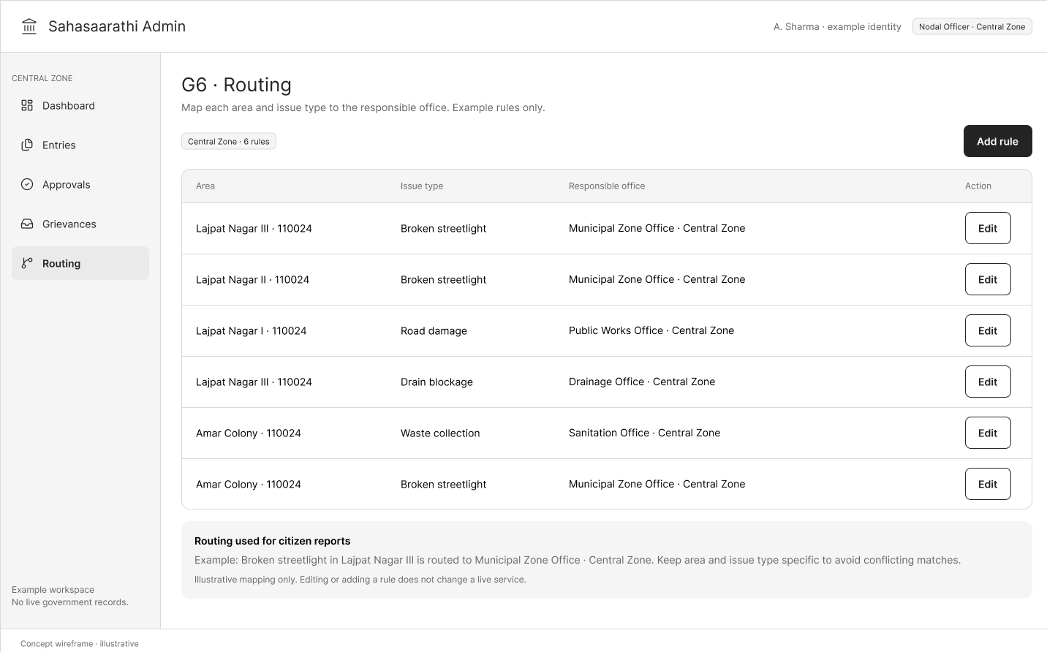
Screen G6: Routing settings
A table that maps area and issue type to the responsible office, with Edit and Add rule, so that reports reach the right desk.

8.4 How the two sides connect
Connection | What happens
Screen 06 to Screen G5 | A report filed by the citizen appears in the grievance inbox of the responsible office.
Screen G4 to Screen 04 | When a supervisor approves a change, the citizen answer card and its last verified date update.
Screen G5 to Screen 09 | When an officer updates the status or adds a note, the citizen sees it in the tracking screen.

These three links form one loop: what citizens see comes from entries that officials have verified, and what citizens report reaches the officials who must act on it.

9. Iteration and Analysis
Iteration happened at two levels: at the concept level before drawing, and at the wireframe level across versions.

9.1 Concept iterations
Iteration | Before | After | Reason
Depth of service | Information and routing only, with links to portals | Three tiers of in-app filing | The citizen should not have to leave the app, and the government side gains a real grievance inbox
Geography | Either one city or national coverage | Layered design with a Delhi-NCR pilot | Keeps the pilot concrete while keeping reach
User research method | Interviews with citizens and officials | Assumption-based personas | The assignment treats user research as personas, and interviews are a recommended next step
Use of earlier work | Side project decision tree considered in full | Only the routing, fallback and escalation ideas kept | The policy suggestion branch is outside the client focus

9.2 Wireframe version 1 to version 2
Version 1 contained the eight public screens. Reviewing it against the brief showed gaps, which version 2 closes.
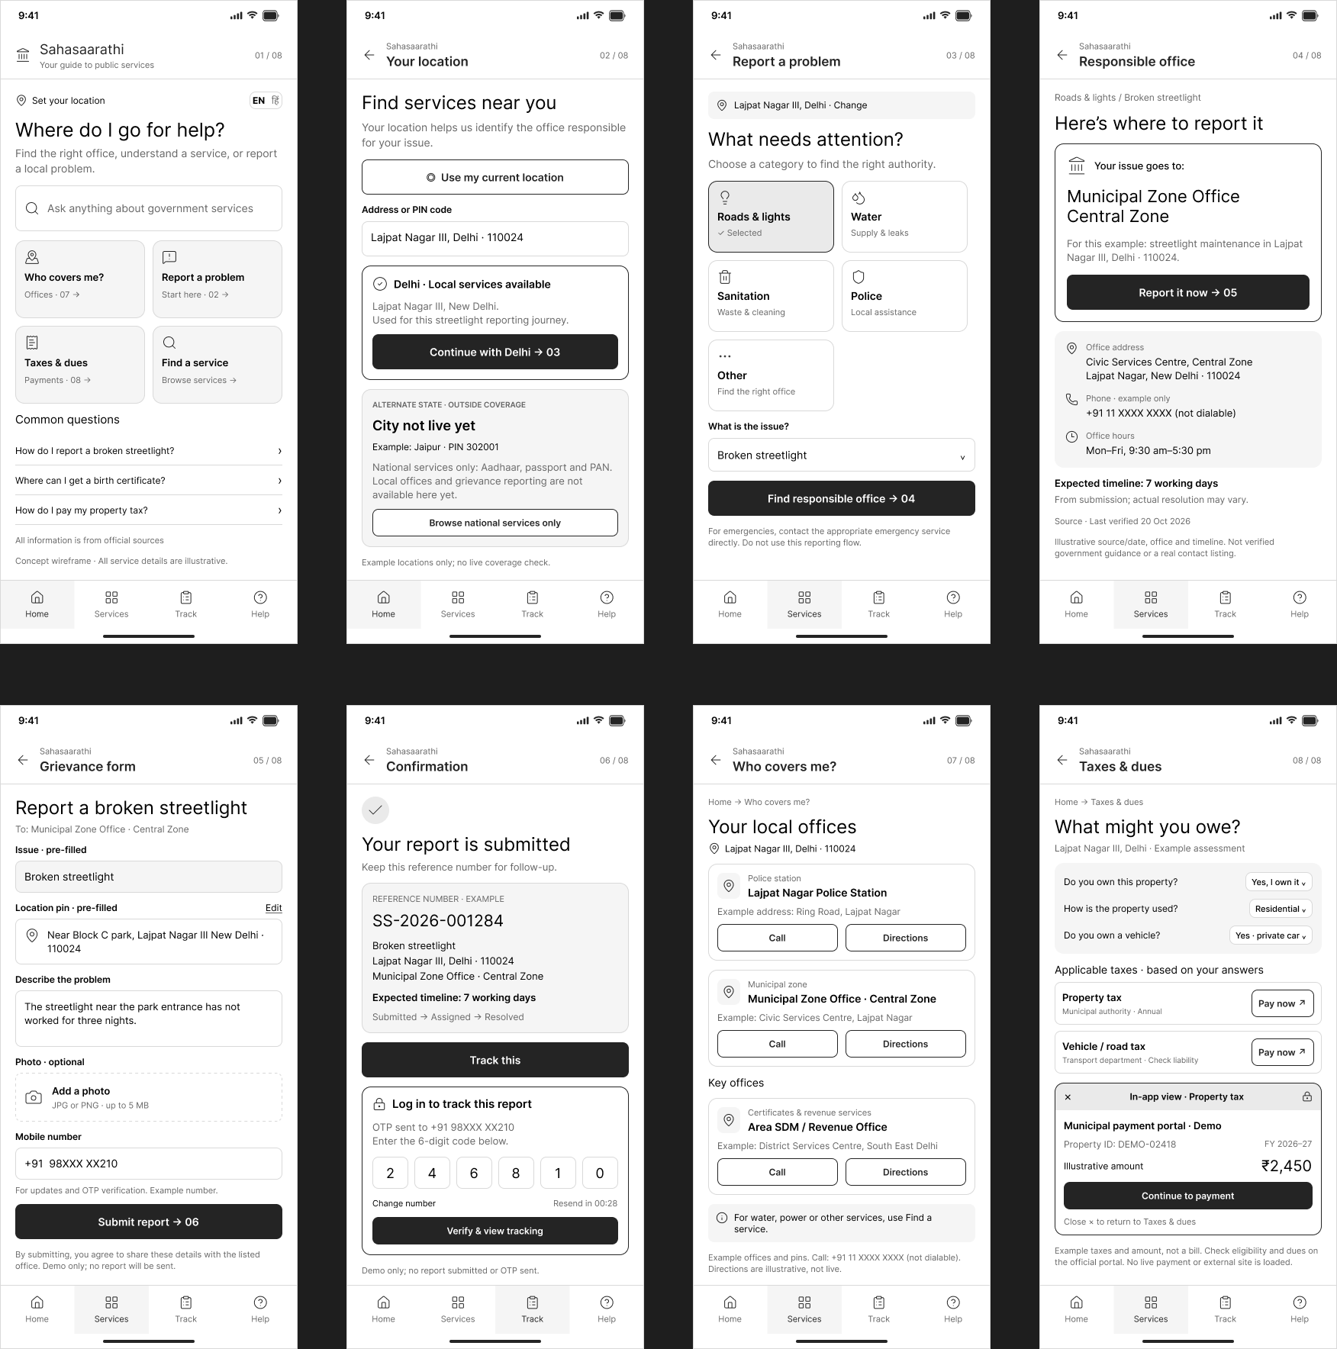
Figure 4: Wireframe version 1 (public side, 8 screens)
Observation in version 1 | Change in version 2 | Reason
No screen after Track this | Added Screen 09, Track report | The citizen needs to see status after filing (C6)
No government side | Added Screens G1 to G6 | The client is the government side, and it supplies the information
Citizen reports had no destination | Connected Screen 06 to the inbox in G5 | Shows the loop between the two sides
Approved changes had no visible effect | G4 states that publishing updates the answer card | Shows how verification builds trust (C4, G5)

9.3 Review of version 2 and planned version 3 changes
A review of version 2 found the following points. They are planned for version 3.
# | Observation | Planned change | Reason
1 | Screen 07 shows the police station but not the officer in charge | Add the officer in charge, using published contact details only | The client named police information as an example
2 | Hindi appears only as a toggle | Add a Hindi version of the home screen | Shows inclusive access (C5)
3 | Screen 09 shows only a resolved report | Add an in-progress state with the Escalate button active | Shows the value of tracking
4 | The government header names A. Sharma while the officer note names A. Verma, and G4 shows a nodal officer chip on a supervisor screen | Use one officer name and show the Supervisor role on G4 | Consistency with the personas
5 | Screen counters read 01 of 08 to 08 of 08, but the Track screen reads 09 of 09 | Update all counters to 09 | Consistency
6 | Find a service has no destination | Add a short list of central services, or mark it as future scope | Completes the central layer
7 | Connections between the two sides are described but not drawn | Add labelled arrows between the frames in Figma | Makes the loop visible

10. Assumptions, Risks and Open Questions

10.1 Assumptions
ID | Area | Assumption
A1 | Geography | The pilot covers Delhi-NCR, with a layered design that extends to other cities
A2 | Departments | Police, municipal services and taxes are covered in version 1
A3 | Integration | Verified content plus tiered in-app filing, with no deep integration in version 1
A4 | Data ownership | A nodal officer enters information in each department and a supervisor approves it
A5 | Restricted information | Only officially published information is shown, with no personal data
A6 | Government users | Staff have basic digital literacy and use the government side on a desktop
A7 | Public users | Mobile-first, simple language, English and Hindi
A8 | Login | Browsing needs no login, and OTP login is used only for tracking and reminders
A9 | Budget | INR 5 lakh covers the whole project, so the product favours routing and content over integration

10.2 Risks and mitigations
ID | Risk | Mitigation
R1 | Departments may not join the platform for in-app filing | Tier 2 and tier 3 fallbacks keep the citizen journey working
R2 | Official portals block embedding or change often | Link out with the office address and phone as a fallback
R3 | Information goes stale | Ninety-day verification flags and a supervisor approval flow
R4 | Privacy of grievance data | Collect the minimum details, verify by OTP, and show no personal data publicly
R5 | Reports reach the wrong office | Routing rules with a simple reassignment option on the government side

11. Conclusion
The wireframe translates the brief into 9 public mobile screens and 6 government desktop screens. On the public side, a citizen moves from the home screen and location to the responsible office, files a grievance in the app, and tracks it to resolution, with jurisdiction and tax information one tap away. On the government side, staff sign in, update verified entries, approve changes, handle the grievance inbox and set routing rules. Together, the screens show the loop between the two sides: verified information flows from officials to citizens, and citizen reports flow back to the officials who must act on them.

Annexure A: Prompt Sheet

User's Prompt:
[Attached image 1: rubric table with columns Criteria / Weightage / PLO, CO-PO, Excellent (5), Very Good (4), Good (3), Average (2), Needs Improvement (1). Rows: Identify challenges (RBT 3), Identify product opportunities (RBT 3), Make use of relevant wireframe (RBT 3).]
[Attached image 2: handwritten page headed "Rough Notes".]
CIA 1 - Wireframing for Product Development Students are expected to act as product managers and develop a wireframe for a new digital product or application. Students are further expected to follow the iterative design process, considering the user needs, market trends and usability principles to create an effective wireframe. This is an in-class activity. Steps:
- Choose a product
- Conduct user research
- Define Goals and Features
- Sketch Wireframes
- Analyse and Iterate
- Document Deliverables:
- Report with prompt sheet
- Wireframe
- Video - 1-3 minutes demo
2nd image attached is the rough notes created for the intended product during meeting with the prof (read client; prof is our mock client). The product is for the use of govt servants & the general public. Focus is to provide a unified platform to solve for the govt sourced info fragmented across govt sources (digital/paper) and make it easily accessible to the public. Needless to say there will be 2 sides for the product as such- govt servant side & general public side
Do you understand till here?
Claude's Reply:
Yes, I understand. Here's my read of what you've shared, so you can correct anything I've got wrong.
The assignment (CIA 1) You act as a product manager and produce a wireframe for a new digital product, following an iterative design process (choose product → user research → goals and features → sketch → analyse and iterate → document). It's an in-class activity. Deliverables are:
- Report with prompt sheet
- Wireframe
- 1-3 minute demo video
The rubric (first image) The criteria I can see are Identify challenges (RBT 3), Identify product opportunities (RBT 3) and Make use of relevant wireframe (RBT 3), each mapped to CO1/PO1 and scored from 5 (Excellent) down to 1. The table is cut off at the page edge, so there may be more criteria below. The top scores reward identifying all main issues clearly, identifying opportunities relevant to the product with a clear description, and giving a clear description of the solution with supporting opinions and a suitable solution.
The client brief (your handwritten notes) The product is a unified app for the general FAQs people have about public infrastructure (physical or digital) and government-owned information. It has two sides, a government side (municipal/state) and a public side. Example use cases from your notes:
- Which local thana/jurisdiction your home falls under
- Information on police personnel
- How to register grievances, and where, since digital infrastructure is fragmented
- Which different taxes people can or have to pay
Your notes cut off mid-line after "taxes", so there may be more examples.
Your framing The core problem is that government-sourced information is fragmented across digital and paper sources. The product consolidates it and makes it easily accessible to the public. Government servants are the supply side who keep the information accurate, and citizens are the demand side who search it.
Things I'd want to clarify before we start
- Rubric: Is there more below the cut-off, such as criteria on user research, iteration or documentation? That would shape the report.
- Scope: Is it one city or state (e.g. Delhi-NCR/UP) or national? This affects how we handle jurisdiction.
- Tools: What are you wireframing in (Figma, Balsamiq, pen and paper)? Since it's an in-class activity, how much time do you have?
- Prompt sheet: Is this a log of the AI prompts you used, or something else?
Tell me where you'd like to begin: user research and personas, the problem statement, or the feature list for each side.

User's Prompt:
Report will must have the following- User research (user persona) Defined goals & features Screenshot or Sketch of Wireframe Minutes of the Meeting (I have it in my notebook) Promptsheet (have to be attached at the end of the report)
Claude's Reply:
Got it. Here's how I'd lay out the report so each section maps to the rubric:
Report section | Rubric criterion it supports
1. Minutes of the Meeting (client brief, requirements, open questions) | Identify challenges
2. User research and personas (public side, government side) | Identify challenges
3. Goals and features (per side, prioritised) | Identify product opportunities
4. Wireframe screenshots with a short walkthrough | Make use of relevant wireframe
5. Iteration notes (what changed from v1 to v2 and why) | Analyse and iterate (a process step)
Annexure: Prompt sheet | Required at the end
Your list doesn't include iteration, but the assignment names "Analyse and Iterate" as a step. I'd add a half-page section on it, since showing a v1 → v2 change is easy evidence of following the process.
Two things to settle early
- User research: Even in an in-class activity, personas look stronger when they rest on something real, like 5-8 quick conversations or a short form with citizens and, if you can, one government employee. You'd then report the findings (e.g. "6 of 8 didn't know which thana covers their home") and build the personas from them. I can draft the questions.
- Prompt sheet: I'd log every prompt we use as we go (prompt, purpose, how you used the output), so you aren't reconstructing it at the end.
Suggested order: start with the Minutes of the Meeting, since it's already in your notebook. Send me a photo of those pages (plus the rest of the cut-off line from your rough notes, if there is one) and I'll turn them into a clean MoM with requirements and open questions. Then we move to research questions, personas, features, and the wireframe flow.
Is that okay, or would you rather start somewhere else?

User's Prompt:
what do you suggest, how should we go on about this?
Claude's Reply:
My suggestion is to work in the order the rubric rewards, build one narrow slice well rather than covering everything, and keep the prompt sheet as we go.
1. Lock the scope (now)
- Pick one pilot geography, such as one city or state, because jurisdiction and grievance routing differ by place.
- Take the four use cases from your notes as the core: jurisdiction lookup (which thana covers my home), police personnel information, grievance registration and routing, and taxes payable. Anything beyond these goes in a "future scope" line in the report.
- Treat the product as a trusted routing layer rather than a new data owner. Government data stays in its source systems. The app gives a verified answer, shows the source and a "last verified" date, and deep-links to the right portal or office. This directly addresses the fragmentation problem and is a strong point for the "identify challenges" criterion.
2. Quick user research (about 30 minutes)
- Ask 5-8 citizens and, if possible, 1-2 government employees.
- Keep it to 5 questions: what they last needed from a government office, how they found it, where they got stuck, what they'd want answered instantly, and (for officials) how they currently handle repeat queries.
- Report the findings as numbers ("5 of 7 didn't know their thana"). I can draft the question set and a tally sheet.
3. Personas and goals (about 30 minutes)
- Three personas: a first-time or low-digital-literacy citizen, a working professional who wants quick self-service, and a government servant who maintains information and handles grievances.
- Features go on a must-have / should-have / later list for each side. Rough shape:
  - Public side: search or guided FAQ, jurisdiction finder, grievance router with status tracking, tax and fee guide, a language toggle, and an offline or "visit the office" fallback.
  - Government side: a content dashboard to add, update and verify entries, a review and approval flow, a grievance inbox, and basic analytics on what people ask most.
4. Wireframe (the biggest chunk)
- Use Figma or whatever is fastest for you, in low-fidelity.
- Two core flows: public (home → ask or search → answer card with source → next action) and government (login → dashboard → edit and verify an entry → publish).
- Build v1, show it to 2-3 people, note what confused them, and make a v2. That gives you the iteration evidence.
5. Demo video (1-3 minutes)
- Write a short script walking one citizen scenario and one government scenario through the wireframe. Record a screen capture with voiceover. I can draft the script once the screens exist.
6. Report assembly
- Minutes of the Meeting, research and personas, goals and features, wireframes, iteration notes, prompt sheet as an annexure. I'll keep a running prompt log from this point, so the annexure is nearly done by the end.
What I need from you next
- A photo of your Minutes of the Meeting pages, plus the rest of the cut-off line after "taxes".
- Your pilot geography and your deadline or in-class time limit, so I can adjust how deep we go.
If you want to start immediately, send the MoM photos and I'll turn them into the clean first section.
Send the MoM photos and your pilot geography and deadline whenever you're ready, and we'll start with the clean Minutes of the Meeting.

User's Prompt:
[Attached image: handwritten Minutes of the Meeting page (Date: 22/10/26, Time: 10:45 am; "Govt Servant (Client) + public"; Focus: solve info flow for govt digital infra; Budget: 5 lakhs; Next discussion: ask Q on this), with the Rough Notes below it.]
Mom image with rough notes below it I have access to figma & our prof recommended it too I also have something I was working on as a side project on a similar issue, wanna see if it has any utility here?
Claude's Reply:
Yes, send it over. Share a link, screenshots, or a short description, and I'll check whether it works as research evidence, a UI pattern reference, or a ready-made component. One caution: the CIA is graded on your own wireframing process, so it should inform the work rather than replace it. If we use it, we'd disclose it in the report and prompt sheet.
Here's a clean Minutes of the Meeting from your notes:
Minutes of the Meeting
- Date and time: 22/10/2026, 10:45 am
- Participants: Client (government servant side), project team
- Focus: Solve the information flow for government digital infrastructure
- Users: Government servants (client) and the general public
- Budget: ₹5 lakhs
- Requirements discussed: A single app answering general FAQs about public infrastructure (physical or digital) and government-owned information, with a government side (municipal/state) and a public side. Example needs: which thana or jurisdiction a home falls under, police personnel information, how and where to register grievances, and which taxes apply.
- Challenge raised: Government digital infrastructure is fragmented, so people don't know where to go.
- Next step: Prepare questions for the next discussion.
Two things to check in your notes
- The line after "Govt Servant (Client) +" has a small word above the plus sign. I read it as "co", but I'm not sure. Is it "co-user" or something else?
- Your notes list only one client side. Does the client want the government side to be the primary design focus?
What the ₹5 lakh budget means for the design It suggests the product should route and verify rather than rebuild or integrate with every department's system. That fits the "trusted routing layer" idea, and it also gives you a concrete constraint to cite under "identify challenges."
I can draft the questions for the next discussion with the client next. Do you want that before or after you share the side project?

User's Prompt:
[Attached image: flowchart titled "Civic Action Decision Tree (India)" — branches: What Type of Issue? (Service Problem / Policy Suggestion–Law Change / Information Needed) → Which Level? (Local, State, Central; Ministry/MP/MLA; Is Info Public?) → Grievance Portal Available? → Submit on Portal / Send Email → Resolved in 30 Days? → Resolved / Escalate or File RTI; Track Ref. Number, Follow Up in 7 Days; Send Policy Proposal, File RTI Request.]
this is the chart from my personal side project
Claude's Reply:
Yes, this is useful, mainly as the logic behind the public side of the app. Your chart is the "as-is" journey, where the citizen has to work out the issue type, the government level and the next step on their own. The app's job is to take that burden away, which is the strongest framing you can give the client.
Where it fits
- Identify challenges: The chart shows how many decisions a citizen has to make before reaching the right office (issue type, local/state/central, portal or email, 30-day follow-up). You can use it in the report as the current-state problem map, credited as your team's prior exploratory work.
- Grievance router (public side): The left branch becomes the core flow. The app decides the level from the user's address instead of asking them, then gives the correct portal and a status tracker.
- Escalation reminders: The "resolved in 30 days?" step can become a built-in reminder that nudges the user to escalate or file an RTI.
- Information requests: The right branch can become a simple "is this published, or do I need to file an RTI?" guide.
- Budget fit: It's rules-based routing, with no deep integration with each department's systems, which suits the ₹5 lakh constraint.
What I'd change before using it
- Drop the "Policy suggestion / law change" branch. The client's focus is information flow for government digital infrastructure, and this branch is outside that. Park it as future scope.
- Add the government side. The chart is citizen-only, but the client is the government servant. We need the mirror view: who receives a grievance, who verifies the information, and how it gets updated.
- Fix the logic on the right branch. "Info available" currently leads to "Send Policy Proposal," which belongs to a different journey. Available information should lead to "here it is, with the source."
- Check the numbers before they go in the report. The 30-day and 7-day timelines vary by portal and state, so verify each against the official source or show them as indicative.
- Cover the gaps against your notes. The chart doesn't touch jurisdiction lookup (the thana example), police personnel information, or taxes, which the client mentioned.
Suggested next step I'd draft the questions for the next client discussion, since your notes say that's the next step and the answers will settle several of the points above, especially the government-side workflow. After that we build the research questions and personas.
Want me to start on the client questions?

User's Prompt:
as a I said, it is from a side project. We need not take it as it is but only what we need or is of utility
Claude's Reply:
Understood, and fair. I'll treat the chart as a source of ideas rather than something to correct. What's worth carrying over:
- Level-based routing: the app works out whether an issue is local, state or central, so the citizen doesn't have to.
- Portal or fallback: if there's a grievance portal, link to it, and if not, say what to do instead.
- Follow-up and escalation: a reminder to check in and escalate if there's no resolution.
- Info available or not: show the information with its source, or guide the user to request it.
Everything else is left behind. Next is the client questions, since your notes mark that as the next step. These are grouped so you can ask them in order:
Scope and users
- Which geography should the first version cover (one city, one state, or national)?
- Which departments or offices should be in scope at launch (police, municipal, tax, others)?
- Who are the government users, and roughly how many? Are they field staff, clerks or senior officers?
- Which public users matter most, and should we plan for low digital literacy or regional languages?
Current state and pain points 5. Where does this information live today (portals, paper records, office registers, individual staff)? 6. What do citizens ask most often, and what are the biggest complaints about getting information? 7. How are grievances received and tracked now, and where do they get lost or delayed?
Requirements and constraints 8. Who owns and verifies the information, and how often does it change? 9. Is there any information that must not be public, such as police personnel details? What is the rule? 10. Does the app need to connect to existing portals or databases, or can it link out to them? 11. How should citizens log in (Aadhaar, mobile OTP, no login), and are there privacy requirements?
Success and budget 12. How will success be measured (fewer office visits, faster grievance resolution, usage)? 13. Does the ₹5 lakh cover design only, or build and maintenance too? What timeline are we working to?
If the client can only give you a few minutes, questions 1, 5, 9 and 10 matter most. Want me to start the research questions for citizens next, or would you like to adjust this list first?

User's Prompt:
So how should we go about it?
Claude's Reply:
Don't wait for the client's answers. Run two tracks in parallel, and work with clearly labelled assumptions until the client confirms.
Track 1: Client (you) Take the 13 questions to the next discussion, prioritising 1, 5, 9 and 10. Write the answers into the report as a "Minutes of Meeting 2". Where they change something, that's your first iteration.
Track 2: Citizen and official research (start now)
- I draft a 5-question interview guide and a tally sheet.
- You talk to 5-8 people (friends, family, neighbours) plus 1-2 government employees if you can reach any. It takes about 10 minutes each.
- You send me the notes, and I turn them into findings with counts.
Then, in order
- Personas: three, built from the research (a low-digital-literacy citizen, a self-service professional, a government servant).
- Goals and features: a must-have / should-have / later list for each side, with assumptions marked.
- Wireframe v1 in Figma: two core flows. The public flow runs from a question to an answer card with source, then the grievance router. The government flow runs from login to dashboard, then verify or update an entry, then the grievance inbox. I'll give you a screen list and layout notes per screen so Figma goes quickly.
- Test and iterate: show v1 to 2-3 people, record what confused them, build v2, and log the changes.
- Demo video: a 90-second script with one citizen scenario and one government scenario.
- Report assembly: MoM 1 and 2, research, personas, features, wireframes, iteration notes, prompt sheet.
Running in the background I'll keep the prompt log as we go, so the annexure is ready at the end.
I'd do the research guide first, since it needs your time away from the screen and the rest depends on it. Shall I draft it now?

User's Prompt:
What questions you want answered from the client (prof; he is the mock client)
Claude's Reply:
These are the questions I'd want answered, in priority order. Since the prof is playing the client, ask for decisions rather than facts he'd have to look up, and write down his answers as the assumptions we design to.
Must-have answers
- Geography: Which city or state is the first version for? This decides how jurisdiction and grievance routing work.
- Departments in scope: Which should be in the first version (police, municipal, tax, others)? We need a cap on scope.
- Integration: Should the app connect to existing portals and databases, or just link out to them? This is the biggest driver of what we wireframe, and it ties to the ₹5 lakh budget.
- Data ownership: Who on the government side enters, verifies and updates the information? This defines the whole government-side flow.
- Restricted information: Is any of it not for public view, such as police personnel details? What is the rule? This affects the information-sharing screens.
Good to have 6. Government users: Who are they (clerks, field staff, officers), and are they comfortable with digital tools? 7. Public users: Which citizens matter most, and do we need regional languages or low-literacy support? 8. Login: Should citizens log in (OTP, Aadhaar) or use it without an account? 9. Success measure: How will he judge it (fewer office visits, faster grievance resolution, usage)? 10. Budget and timeline: Does the ₹5 lakh cover design only, or build and maintenance too?
If he only gives you a few minutes, ask 1, 3 and 4 first, because those shape the wireframe the most.
Once you have the answers, send them to me and we'll lock the scope and move to the research guide and personas. Want me to draft the citizen research guide in the meantime?

User's Prompt:
For our 1st assignment, we only have to submit wireframe, report, video demo & promptsheet (attached inside the report) as mentioned earlier
As for your queries, question 1 - 8 is for us to decide. The answer to question 9 is that it depends on the rubrics of each assignment (like the rubric for this assignment has also been attached earlier). 5 lakh budget is for the entire project, end to end, not just the wireframe
Claude's Reply:
Understood, so the report holds everything except the separate wireframe and video: Minutes of the Meeting, research and personas, goals and features, wireframe screenshots, a short iteration note, and the prompt sheet at the end. Success is judged by the rubric, so we'll aim at its three criteria: challenges, opportunities and the wireframe. The ₹5 lakh covers the whole project, so we'll keep the product lean.
For questions 1-8, here are my recommended decisions. Change anything you disagree with, and I'll treat them as our stated assumptions.
- Geography: One pilot city, preferably where you can easily interview people (e.g. your own area in Delhi-NCR).
- Departments: Three modules that match your notes: police (jurisdiction and station information), municipal (grievances and civic services), and taxes.
- Integration: Verified content plus links to the official portals. No deep integration in version 1, which fits the budget.
- Data ownership: Each department has a nodal officer who enters information and a supervisor who approves it. Every entry shows its source and a "last verified" date.
- Restricted information: Only officially published information is shown (station contact numbers, duty officer details as published). No personal data.
- Government users: Nodal officers (content editors), supervisors (approvers), and grievance handlers, assumed to have basic digital literacy.
- Public users: Any citizen, with a mobile-first design, simple language, and English plus Hindi.
- Login: Browsing needs no login. OTP login is only for grievance tracking and reminders.
With these fixed, the next step is the citizen and official research guide. Do these decisions work, or do you want to change any?

User's Prompt:
I wanna discuss how should we scope it & why, which is what Q1 & Q2 are essentially about
Claude's Reply:
A good scope is the smallest one that still shows the problem, the opportunity and a working wireframe. Three things set the limits here: the ₹5 lakh covers the whole project end to end, the rubric rewards clear challenges and opportunities rather than breadth, and the problem is fragmentation, which is a jurisdiction problem at its core.
Q1: Geography
Option | For | Against
National | Big vision | Every state has different portals, so the jurisdiction logic and content are unmanageable on this budget
One state | Police and municipal law are state matters, so it's a natural unit | Still very large to research and wireframe
One city (pilot) | Jurisdiction can be defined concretely, you can interview real people, and the examples in the report are real | Needs a "scales to other cities" argument
I'd recommend a city pilot, designed so it extends to a state. The core mechanism is address in, correct office and portal out. It works the same in any city, so the pilot proves the idea and the report can say how it scales. Pick a city where you can interview people easily, ideally one where a single home can fall under confusing overlapping authorities. That makes the "fragmentation" story vivid, and in Delhi-NCR, for example, the boundaries between Delhi, UP and Haryana already create it.
Q2: Which departments or modules
I'd filter candidates with four questions:
- Did the client name it?
- Do citizens need it often?
- Does fragmentation hurt there?
- Is the information safe to publish?
On that filter, three modules sit on one shared spine:
- Spine: "Who covers me?" A jurisdiction finder that takes an address and returns the police station, municipal zone and relevant offices. This is the foundation, and it covers your thana example. Police personnel information joins here, but only as officially published contact details.
- Module 1: Grievances. Where to file, how, and how to track it. This is the sharpest pain point.
- Module 2: Taxes and dues. Which ones apply to you, who collects them, and where to pay. It's frequent and rule-based, so it's easy to wireframe.
I'd leave out utilities, certificates, transport and the like, and list them as future scope. They're real needs, but each adds another set of portals and rules.
Why three rather than one? A single module gives you thin "opportunities" for the rubric. Why not six? The wireframe would turn shallow, and the budget wouldn't support it. The shared spine is also your strongest design argument, because every module reuses the same engine.
Three separate scopes for the report
- Product scope: the spine plus two modules, in one pilot city.
- Wireframe scope: the core flows only (finding your jurisdiction, filing a grievance, the government verify-and-update flow).
- Future scope: more modules, more cities, deeper integrations.
Keeping these apart lets the report show you made deliberate trade-offs.
Which city do you want to use, and are you comfortable with the three-module scope? Once you decide, I'll write it up as a short scoping rationale for the report.

User's Prompt:
why will I interview people?
Claude's Reply:
Because the assignment asks for it. "Conduct user research" is step 2 of the process, and the report must include user research and personas. The rubric's top score for "identify challenges" goes to identifying all the main issues clearly, and real evidence makes that much easier to defend.
What interviews give you that I can't
- Real evidence: I can suggest likely problems, but they'd be guesses. A line like "5 of 7 people didn't know which police station covers their home" is a finding, and it can be checked.
- Personas that hold up: Personas built from real answers are more convincing than invented ones. If the prof asks how you know, you have an answer.
- Surprises: People often describe problems nobody predicted, and those make the best design decisions.
It doesn't have to be a big exercise
- Minimum: 5 people, about 5 minutes each, by call, in person or over WhatsApp voice notes.
- Faster alternative: a short Google Form with 5-6 questions sent to your class and family groups. You could get 20+ responses with little effort, and the counts look good in the report.
- For the government side: one conversation with anyone who works in a government office is enough. If you can't reach anyone, we label that side of the personas as assumptions, drawn from the client meeting and public sources, and say so openly.
I'd go with the form for the numbers plus 2-3 short conversations for the quotes. Together that takes under an hour.
Want me to draft the form questions and the short interview guide now?

User's Prompt:
user research = user persona actually
Claude's Reply:
Got it. That was my mistake: your report lists "User research (user persona)" as one item, so the personas are the research deliverable and no interviews are required. We'll build them directly from what we have: the client meeting, your side project's journey map, and general knowledge of how these services work. In the report, I'd label them as assumption-based personas drawn from the client brief, so it's transparent. If you later get 2-3 quick conversations, that's a bonus rather than a requirement.
Here's a draft of three personas. The names and details are placeholders you can change.
1. Ritu Sharma, 34, working professional (public side)
- Context: Recently moved to a new neighbourhood and comfortable with apps, but short on time.
- Goals: Find out which police station and municipal office cover her new home, file a civic complaint, and know which taxes she owes.
- Pain points: Information is scattered across several portals, she can't tell which one is right, and she gets no updates after filing a complaint.
- Uses the app to: Enter her address, see her jurisdiction, file and track a grievance.
2. Ramesh Yadav, 58, first-time or low-digital-literacy citizen (public side)
- Context: Long-time resident who relies on his son or a local office for anything official, with a basic smartphone and a preference for Hindi.
- Goals: Know where to go in person for a problem, and what documents or payments are needed.
- Pain points: Portals are confusing and in English, he's often sent between offices, and he can't tell whether a website is genuine.
- Uses the app to: Browse in Hindi, get a plain "go here, bring this" answer, and see an official contact number.
3. Anita Verma, 41, municipal nodal officer (government side)
- Context: Handles records and public queries at a municipal office, with moderate digital comfort and a heavy workload of repeat questions.
- Goals: Keep information accurate, reduce repeat queries at the counter, and handle grievances without losing track.
- Pain points: Information lives in registers, PDFs and several portals, updates take effort, and she has no single view of pending grievances.
- Uses the app to: Update and verify entries, see a grievance inbox, and check what citizens ask most.
A supervisor who approves entries could be a fourth persona, or just a role under Anita. I'd keep three to stay lean.
Do these three cover the right users? Once you've adjusted them, I'll turn them into a polished persona section and move on to goals and features.

User's Prompt:
let's go back to our scoping question with this clarification
"I wanna discuss how should we scope it & why, which is what Q1 & Q2 are essentially about"
Claude's Reply:
Scoping is about deciding what the product will deliberately not do, and being able to defend that choice. Three constraints drive it here:
- The rubric rewards clarity over breadth. Three criteria (challenges, opportunities, wireframe) are best served by a few problems described sharply, not many described thinly.
- The deliverables are small. A wireframe plus a 1-3 minute demo can only carry about two or three flows convincingly.
- The budget is ₹5 lakh for the whole project. The scope has to be plausibly buildable at that size, which pushes you towards routing and verified content rather than deep integrations.
The four things you're scoping
- Who: which users the first version serves. Both sides are required, but one can be primary.
- What: which problems and information types it covers (Q2).
- Where: how much geography it covers (Q1).
- How deep: whether it only tells people where to go, or also completes the task for them.
A tension in your notes to resolve first The meeting note says the focus is to "solve info flow for govt digital infra," but your example list (thana jurisdiction, police personnel, taxes) covers physical offices and institutions as well. That gives two readings:
- Narrow: the app is about the fragmentation of government portals and digital services, meaning which portal, for what, and how to use it.
- Broad: the app covers the whole "who do I go to, and how" problem across offices, police, taxes and portals.
I'd take the broad reading with a digital-first core, because your examples show the prof wants the broader problem. The reasoning is that the digital portals are exactly where people get lost, so they stay central while offices appear as the fallback answer. Raise this with the prof as the first scoping question, since his answer settles Q2.
What follows from that
- Q1 (where): one pilot city. The reason is that jurisdiction is the one problem that needs a concrete place to make sense, and the mechanism (address in, correct authority and portal out) is the same everywhere, so it scales.
- Q2 (what): a "who covers me?" jurisdiction finder as the base, plus grievances and taxes as the two modules. Each is named in your brief, frequent for citizens, and clearly hurt by fragmentation.
- How deep: information and routing only, with links to official portals. Filing and payment stay on those portals in version 1.
A draft scope statement for the report would read: "A pilot for one city that helps citizens find the right authority, portal and procedure for jurisdiction, grievance and tax queries, and gives government staff a way to keep that information verified and current. Transactions, other departments and other cities are future scope."
Does the broad-with-digital-core reading match what the prof said, or did he lean towards the narrow one?

User's Prompt:
next meeting with prof/client is post this assignment submission so we have to decide it/take a judgement call
Claude's Reply:
Then we make the calls ourselves and show our reasoning in the report. A judgement call you can justify scores better on "identify challenges" and "identify opportunities" than a question left open. The client questions don't go to waste either: they become an "Assumptions and open questions" section, which shows a product manager's habit of stating what they decided and what they'd confirm next.
The calls I'd make
- Reading of the brief: broad, with a digital-first core. Your examples (thana, police personnel, taxes) go beyond portals, so the app has to answer "who do I go to and how." The portals stay central because that's where people get lost.
- Geography: one pilot city. Jurisdiction can only be shown concretely in a real place, and the mechanism (address in, authority and portal out) works the same elsewhere, so scaling is an argument rather than extra work.
- Scope: a "who covers me?" jurisdiction finder as the base, plus grievances and taxes as two modules. All three are in the brief and are frequent needs, and fragmentation hurts in each.
- Depth: information and routing only. Filing and payment stay on the official portals in version 1. This fits a ₹5 lakh end-to-end budget.
- Public data only. For police, that means published station and contact details, with no personal data.
- Both sides designed, with the government side leaner. It needs content entry, approval and a grievance inbox, and no analytics in version 1.
Why this holds up if the prof challenges it
- It maps to every example in his brief.
- It's buildable within the budget.
- It leaves a clear future-scope list: more departments, more cities, transactions, deeper integrations.
One decision I need from you: which city? It matters because the examples in the report, and any screenshots of real portals, will use it. I'd pick a city whose boundaries are genuinely confusing, since that makes the fragmentation problem easy to see. Delhi-NCR is a strong choice for exactly that reason, because Delhi, UP and Haryana authorities sit side by side. Do you agree, or would you pick somewhere else?

User's Prompt:
I also lean in favour of broad as people lack even the awareness of such service/platforms/portals leading to the “who do I go to, and how” problem. As for the city, the way I see it, we can make it city specific or city antagonistic i.e. only central govt related stuff. The former has the advantage of being more concrete in a way and latter has better widespread use potential
Claude's Reply:
Your point about awareness is worth adding to the report. It means there are two separate problems: people can't find the right portal, and they don't know a service exists at all. That strengthens the "identify challenges" section.
On city-specific versus city-agnostic, I'd recommend neither on its own:
 | City-specific | City-agnostic (central only)
Concreteness | High, with real offices and boundaries | Lower
Fit with the brief | Covers thana, police, municipal, local taxes | Misses most of the client's examples, which are local and state matters
Reach | One city | Everyone in India
Severity of the problem | Fragmentation is worst here | Central portals are fewer and better known
Central-only has a real weakness. Your client's examples are mostly local, so a central-only product would drop most of what he asked for, and the problem it solves is the smaller one.
My suggestion: a layered design that treats the two as parts of one product
- Central layer, works for everyone: services and portals that are the same nationwide, such as grievance portals, RTI, tax filing, and identity documents. It needs no location.
- Local layer, plugged in per city: jurisdiction, police stations, municipal grievances, and local taxes. You build it fully for the one pilot city.
- Fallback for uncovered cities: the user sees the central layer, general state-level guidance, and a "your city isn't live yet" message.
This mirrors how Indian governance is already layered (local, state, central), which is also the structure in your side project's chart. It gives the report both advantages: the pilot city provides the concreteness, and the architecture provides the widespread-use argument. Scaling then means adding one more city's data rather than rebuilding the app. It also fits the budget, since the central layer is built once and each city is incremental content.
For the wireframe, this adds one extra screen at the start (address or city entry) and the "city not covered" state, which is a nice detail to show.
Do you agree with the layered approach? If so, the last open decision is the pilot city. I'd still lean towards Delhi-NCR, because overlapping Delhi, UP and Haryana authorities make the local problem easy to demonstrate.

User's Prompt:
Layered solution sounds the best & yes Delhi-NCR is the best pilot city
Claude's Reply:
Scope is locked. Here's the summary for the report's scoping section:
- Reading of the brief: Broad. The problem is "who do I go to, and how," made worse by low awareness that services and portals exist.
- Architecture: Layered. The central layer works for everyone, and the local layer is built fully for one city.
- Pilot city: Delhi-NCR, where overlapping Delhi, UP and Haryana authorities make fragmentation easy to see.
- Modules: A "who covers me?" jurisdiction finder as the base, plus grievances and taxes.
- Depth: Information and routing, with links to official portals. Transactions are future scope.
- Data: Public, officially published information only.
- Both sides: Public and government, with the government side leaner.
Next: goals and features. Here's a first pass, split by side and prioritised.
Public side
- Must have:
  - Address or city entry (with the "city not covered" fallback)
  - "Who covers me?" result: police station, municipal zone, key offices
  - Guided grievance router (what's the issue → right authority and portal → how to file)
  - Tax and dues guide
  - Search or FAQ in plain language
  - English and Hindi
  - Source and "last verified" date on every answer
- Should have:
  - Grievance tracker with an OTP login
  - Reminders to follow up or escalate
  - Saved addresses
- Later:
  - In-app filing and payment
  - More departments and cities
  - Voice search
Government side
- Must have:
  - Login by role (nodal officer, supervisor)
  - Content dashboard to add and edit entries
  - Approval flow before publishing
  - Verification dates with expiry alerts
- Should have:
  - Grievance inbox with status updates
  - Basic view of most-asked questions
- Later:
  - Full analytics
  - Integration with department systems
Goals for each side would sit above this list, one or two lines each. For example, the public goal is "any citizen finds the right authority and next step in under a minute," and the government goal is "keep verified information current with minimal effort."
Does this feature split look right, or do you want to move anything between must have, should have and later? After that I'll write up the goals and features section and then plan the wireframe screens.

User's Prompt:
elaborate how both public and govt side look like, paint me a picture
Claude's Reply:
Think of it as one product with two doors. The public door is built for speed and clarity, and the government door is built for accuracy and low effort. Both draw on the same verified information.
The public side: a walk through Ritu's first minute
Ritu has just moved to a flat in Ghaziabad and wants to report a broken streetlight. She opens the app, which is light, bilingual and mobile-first. There's no sign-up wall.
Home screen. A big search bar at the top says "Ask anything about government services," with a language toggle (EN / हिं) beside it. Underneath are four large tiles with icons: Who covers me?, Report a problem, Taxes & dues, Find a service. Below them are a few common questions ("Which police station is mine?", "How do I complain about water supply?"). A small footer note reads "All information is from official sources."
She taps "Report a problem." The app first asks for her location, either by GPS or a typed address or PIN. This is the layered design in action. If her area is in the pilot, she sees the full local experience. If not, she gets the central services plus a friendly "Your city isn't live yet" card.
Step one: what's the issue? She picks from simple categories with icons (roads and lights, water, sanitation, police, other). She taps "Roads and lights."
The answer card. This is the heart of the product. A card says:
- "Your issue goes to: Ghaziabad Municipal Corporation, Zone 3"
- Where to file: a button linking to the official grievance portal, with a one-line "what you'll need" (photo, location, your phone number)
- If the portal is down or you prefer offline: the zone office address, phone number and opening hours
- Expected timeline: "Usually acknowledged in X days"
- Footer: Source: official municipal portal · Last verified 12 Oct 2026
If she wants updates, an optional "Track this and remind me" asks for an OTP login. If nothing happens after the expected timeline, the app nudges her with the next step (escalate to the higher office or file an RTI).
"Who covers me?" works the same way. She types her address and gets a clean result: police station, jurisdiction of the municipal zone, nearest key offices, each with contact details and a map pin. Nothing personal appears, only officially published information.
Taxes and dues. A short guided set of questions ("Do you own property? Do you run a business?") produces a plain list: which taxes apply, who collects them, and the official link to pay.
Ramesh, who prefers Hindi and a simple layout, sees the same app. The language toggle, larger tiles and "go here, bring this" wording make it work for him as well.
The government side: a morning in Anita's day
Anita is a nodal officer at the municipal office. She opens the app on a desktop browser, since this side is mainly used at a desk. It's calmer and more utilitarian than the public side, more like a simple back office.
Login. She signs in with her official credentials. The app recognises her role (nodal officer) and her department.
Dashboard. Four cards across the top:
- Needs attention: entries about to expire (e.g. "6 entries not verified in 90 days")
- Pending approval: entries she has submitted that are waiting for her supervisor
- New grievances: the count of complaints routed to her zone
- Most asked this week: the top public queries, so she knows what to keep fresh
Below the cards is a table of her department's entries (title, last verified date, status). Anything stale is flagged in amber.
Updating an entry. She clicks an entry, say "Zone 3 grievance office." A simple form opens with fields for contact number, address, working hours, portal link and a "last verified" date. She edits the phone number, clicks "Submit for approval," and adds a one-line note on why.
Approval. Her supervisor, Mr. Khan, sees the change highlighted against the old version, approves it, and the entry goes live with a fresh "last verified" stamp. This is the accuracy loop that makes the public side trustworthy.
Grievance inbox. A list of routed complaints with category, location and age. She opens one, changes the status to "Acknowledged" or "Assigned," and adds a short note. The citizen who opted for tracking sees the update.
How the two sides connect
Everything the public sees comes from entries the government side has verified. When Anita updates a phone number, Ritu's answer card changes. When Ritu files a tracked grievance, it appears in Anita's inbox. If an entry goes unverified past its expiry, it's flagged internally and shows a gentle "may be outdated" label publicly. The "last verified" date on the public side exists because the government side keeps it honest.
For the wireframe
The screens fall naturally into two sets, around 6 on the public side and 4 on the government side:
- Public: Home, location entry (with "not covered" state), issue categories, answer card, "Who covers me?" result, tax guide
- Government: Login, dashboard, entry edit and approval, grievance inbox
Would you like me to turn this into a screen-by-screen spec for Figma, listing each screen's elements, layout and the flow between screens? Or I can render quick low-fidelity mockups here first, so you can react to the look before you build.

User's Prompt:
[Attached excerpt from Claude's previous message: "The answer card. This is the heart of the product. A card says: 'Your issue goes to: Ghaziabad Municipal Corporation, Zone 3' / Where to file: a button linking to the official grievance portal, with a one-line 'what you'll need' (photo, location, your phone number) / If the portal is down or you prefer offline: the zone office address, phone number and opening hours / Expected timeline: 'Usually acknowledged in X days' / Footer: Source: official municipal portal · Last verified 12 Oct 2026"]
she should be able to report the problem in the app only or at least the required portal should open within the app itself, the user ideally doesn't have to leave the app. This is from a customer journey pov for as much things as possible
Claude's Reply:
That changes the depth decision I gave you earlier, and I think it's the right change. Keeping people inside the app is a stronger customer journey and a clearer opportunity for the report. The catch is that we can't assume every government portal will cooperate, so the design needs a tiered approach where the user feels they never left the app.
Three levels of "in-app"
Tier | What the user experiences | How it works | When we use it
1. File in the app | A short form inside our app, pre-filled with her location and issue category, then submit | Our app forwards the complaint to the department (by email, a department inbox on the government side, or an API where one exists) and returns a reference number | Where a department joins the platform. This is the ideal case
2. Official portal opens inside the app | The official grievance portal loads in an in-app window under our app's header, with a back button to the answer card | An in-app browser view. Her details are copied or pre-filled where the portal allows | Departments that already have a portal and won't integrate
3. Link out with help | Open the portal externally, with office address and phone as the fallback | A standard link | A last resort for portals that block embedding or are down
The user's experience is the same in tiers 1 and 2: she starts and finishes on our app's screens, and tier 3 is the rare exception.
Why tiers rather than one approach
- Many government portals block being embedded, need their own login or captcha, or change often. A design that depends on all of them cooperating is fragile.
- Tier 1 is the best experience, and it makes the government side much more useful: complaints land directly in the grievance inbox, which is the main value to the client.
- Tier 2 is cheap and works from day one, so version 1 isn't blocked while departments come on board.
What it means for the journey
- Ritu picks "Roads and lights."
- The answer card shows where the issue goes, and the main button now reads "Report it now" rather than "Go to portal."
- A pre-filled form opens (issue type, location pin, photo, phone number) in the app.
- She submits, gets a reference number and an expected timeline, and the grievance appears in her tracker.
- Status updates and the follow-up reminder arrive in the app.
The same principle applies elsewhere: taxes can offer a "Pay now" that opens the official payment page in-app, and the jurisdiction result can offer "Call" and "Directions" buttons so she doesn't have to switch to another app.
Effect on scope and budget
- Filing and tracking move from future scope into version 1, but only for the grievance module. Tax payment stays at tier 2 (the official payment page in-app).
- It adds work to the ₹5 lakh budget: a grievance form, a routing rule per department, and an inbox on the government side. This is modest compared with deep integration with department systems, because we forward the complaint rather than rebuild their back end.
- In the report, state it as an assumption: tier 1 for departments that agree to onboard, tier 2 for the rest.
Effect on the wireframe Three screens are added or changed: the pre-filled grievance form, the "submitted" confirmation with reference number, and the in-app portal view (our header and back button around the official page). The government inbox becomes a core screen rather than an optional one.
Do you want me to now write the screen-by-screen spec for Figma, with this tiered flow built in?

User's Prompt:
from govt side what all purposes it is supposed to serve, list and elaborate
Claude's Reply:
The government side is the supply engine of the product. It exists so that what citizens see is accurate, current and actionable, while making life easier for officials. I'd frame it around seven purposes.
1. Single source of truth for information Departments publish their offices, contacts, jurisdictions, procedures, fees and portal links in one place instead of scattering them across PDFs, registers and several portals.
- Why it matters: This directly attacks the fragmentation problem in the brief.
- In the product: A content dashboard where officers add and edit entries by category (police, municipal, tax) and by area.
2. Accuracy and trust (verification) Information has to be right, or the public side loses credibility fast.
- In the product: An approval flow (officer submits, supervisor approves), a "last verified" date on every entry, expiry alerts for stale entries, and a version history showing who changed what. This is what the "last verified" label on the citizen's answer card depends on.
3. Grievance receiving and resolution Complaints filed in the app arrive in the department's own inbox.
- In the product: A grievance inbox with category, location, photo and age, plus status updates (received, assigned, resolved), notes, and an escalation flag for items past their timeline.
- Why it matters: This is the main benefit to the client, because it replaces scattered emails, letters and portals with one queue.
4. Routing and ownership (who handles what) The app must send each issue to the right authority, which means someone has to define the rules.
- In the product: Admin settings that map areas and issue types to offices, so that "streetlight in Zone 3" reaches the Zone 3 office. Departments can reassign a misrouted grievance, and that correction improves the routing rules over time.
5. Reducing repeat queries and workload A large share of office time goes on the same questions: which office, which form, what the fee is.
- In the product: A "most asked this week" view, so officers can see what citizens need, and fix or add entries to answer it. The citizen answering themselves in the app is what cuts the counter load.
6. Role-based access and accountability Different people should be able to do different things, and every change should be traceable.
- In the product: Roles such as nodal officer (edits), supervisor (approves), grievance handler (resolves) and admin (manages users and routing), with an audit trail. Public data only is published, with nothing personal exposed.
7. Visibility and performance insight for decision-makers Senior officers need to see how things are going without chasing individual staff.
- In the product: A simple summary of grievances received and resolved, average time to resolve, overdue items, and entries that need verification. Detailed analytics can come later.
How these map to the report's rubric
- Challenges: purposes 1, 2 and 5 show the fragmentation and workload problems government staff face today.
- Opportunities: purposes 3, 4 and 7 show what the platform adds, namely one queue, correct routing and visibility.
- Wireframe: the dashboard, entry edit and approval, grievance inbox and routing settings screens come from these seven.
What goes into version 1 and what waits
- Version 1: purposes 1, 2, 3, 4 and 6, kept basic.
- Later: the fuller analytics under purpose 7, and integration with departments' existing systems.
One decision to make: should the wireframe show routing settings (purpose 4), or treat them as a back-office admin setup that stays out of scope? I'd show a single simple screen, because it demonstrates how the "who do I go to" logic is maintained. Want me to include it in the screen spec?

User's Prompt:
so what all we have covered till now
Claude's Reply:
Here's where we stand, mapped to your report sections.
Report section | Status | What we have
Minutes of the Meeting | Drafted | Clean version of the 22/10/26 notes (focus, budget ₹5 lakh, requirements, challenge, next step). One word above the "+" in your notes is still unclear to me
User research (personas) | Drafted, needs your sign-off | Three personas: Ritu (working professional), Ramesh (low digital literacy, Hindi), Anita (municipal nodal officer)
Goals and features | Drafted, needs your sign-off | Must-have / should-have / later lists for both sides, plus a goal line per side. It needs a small update for the in-app filing decision
Scope and rationale | Decided | Broad reading of the brief, layered design (central plus local), Delhi-NCR pilot, a "who covers me?" base with grievance and tax modules, public data only
Wireframe | Planned, not built | About 6 public and 4 government screens identified, plus the pre-filled grievance form, confirmation, in-app portal view, and a routing settings screen
Iteration notes | Not started | Needs v1 first
Prompt sheet | Not compiled yet | I said I'd keep a running log but haven't produced one. I can compile it from this conversation whenever you want
Decisions made along the way
- Next client meeting is after submission, so the questions I drafted become an "Assumptions and open questions" section.
- Your side-project chart is used as inspiration only: level-based routing, portal or fallback, follow-up and escalation, and info available or not.
- Depth changed from information-only to a tiered in-app model: file in the app where a department onboards, open the official portal inside the app otherwise, and link out only as a last resort.
- The government side has seven purposes: single source of truth, verification, grievance handling, routing rules, less repeat workload, role-based accountability and basic visibility. Version 1 covers the first five and the roles part of the sixth.
What's left
- Confirm the personas and the feature split.
- Write the screen-by-screen spec for Figma.
- Build wireframe v1, test it with 2-3 people, and build v2.
- Write the 1-3 minute demo script.
- Assemble the report and attach the prompt sheet.
- Check the rubric: the table was cut off at the page edge, so there may be criteria we haven't seen.
I'd do the confirmations and the screen spec next, since the Figma work depends on them. Do you want to start with the personas and features, or go straight to the screen spec?

User's Prompt:
Give me the complete history our conversation in this chat end to end as it is in the following format-
User's Prompt:
Claude's Reply:
User's Prompt:
Claude's Reply:
format of the file should be docx or md, whatever suits best
Claude's Reply:
I'll compile every prompt and reply from this chat into one file in that format. [The file was delivered as conversation_history.md and a .docx copy.]

User's Prompt:
give me a prompt for figma to design our wireframe & keep it clean, clear and concise
Claude's Reply:
Here's a prompt you can paste into Figma (Figma Make or its AI design feature). It's split so you can run the two sides separately, which usually gives cleaner results.
Prompt 1: Public side (mobile)
Design a low-fidelity, grayscale wireframe for a mobile app (390x844) called "Citizen Services Hub", which gives citizens verified answers about government services in Delhi-NCR. Clean layout, simple icons, rounded cards, plain labels, no photos or brand colours. Use realistic placeholder text.

Create these 8 screens, linked as one flow:
1. Home: search bar ("Ask anything about government services"), EN/हिं language toggle, four tiles (Who covers me?, Report a problem, Taxes & dues, Find a service), three common questions, footer "All information is from official sources".
2. Location entry: GPS button, address/PIN field, and a "City not live yet" state showing national services only.
3. Issue categories: icon grid (Roads & lights, Water, Sanitation, Police, Other).
4. Answer card: "Your issue goes to: [Municipal Zone Office]", a primary "Report it now" button, office address, phone and hours, expected timeline, and a footer "Source · Last verified [date]".
5. Grievance form: pre-filled issue and location pin, photo upload, phone number, Submit.
6. Confirmation: reference number, expected timeline, "Track this" button with OTP login.
7. Who covers me?: police station, municipal zone, key offices, each with Call and Directions buttons and a map pin.
8. Taxes & dues: short guided questions leading to a list of applicable taxes with "Pay now" opening in an in-app view.
Prompt 2: Government side (desktop)
Design a low-fidelity, grayscale desktop wireframe (1440x900) for the government admin side of "Citizen Services Hub", used by municipal officers to keep information accurate and handle grievances. Same style as the public app: clean, minimal, no brand colours.

Create these 5 screens:
1. Login: official ID, password, and role shown after sign-in (Nodal Officer, Supervisor).
2. Dashboard: four cards (Needs attention, Pending approval, New grievances, Most asked this week) above a table of entries with title, last verified date and status; stale entries flagged amber.
3. Edit entry: form with contact number, address, working hours, portal link and last verified date, plus "Submit for approval" and a note field.
4. Approval: supervisor view comparing old and new values side by side, with Approve and Reject buttons.
5. Grievance inbox: list with category, location, age and status; a detail panel with status dropdown (Received, Assigned, Resolved) and a notes field.
Add a small routing-settings screen mapping areas and issue types to offices.
Tips
- Run Prompt 1 first, then Prompt 2 in the same file so the two sides share one style.
- Once both sets are generated, tidy the text and spacing by hand. Generated placeholder content often needs cleanup.
- Keep your v1 frames as they are, then duplicate them for v2 after testing, so you have before and after evidence for the iteration section of the report.
I can also write a short walkthrough of the flows for the report's wireframe section, or draft the demo-video script, whichever you want next.

User's Prompt:
[Attached image: Figma board showing the generated public-side wireframe, 8 mobile screens.]
Figma's Wireframe now we have covered what and left with what?
Claude's Reply:
The public side of the wireframe is done and matches the spec, but the government side hasn't been designed yet.
Covered
Item | Status
Scope decisions (broad reading, layered design, Delhi-NCR pilot, three modules, in-app filing) | Decided
Minutes of the Meeting | Drafted
Personas (Ritu, Ramesh, Anita) | Drafted, awaiting your sign-off
Goals and features | Drafted, needs updating for in-app filing
Government-side purposes (the seven) | Defined
Public-side wireframe v1 | Done, all 8 screens
Figma prompts | Written
Conversation history file | Compiled, but now out of date
Left
- Government-side wireframe: login, dashboard, edit entry, approval, grievance inbox, plus the routing settings screen (Prompt 2).
- Iteration: test v1 with 2-3 people, note what confused them, build v2.
- Demo video: I draft a 90-second script, then you record it.
- Report writing:
  - Finalise the personas
  - Update goals and features
  - Write the challenges and opportunities sections
  - Write the assumptions and open questions section (the client questions)
  - Add the wireframe walkthrough
  - Add the minutes pages from your notebook
- Prompt sheet refresh: the file stops before the latest turns, so I'll regenerate it once everything else is done.
- Small checks: the word above the "+" in your meeting notes, and whether the rubric has more criteria below the cut-off.
What I noticed in the wireframe
All 8 screens follow the planned flow, and the "Report it now" button, pre-filled form, in-app tax payment view and "City not live yet" state are all there. A few gaps could work as your first iteration, since you can show them as findings and fixes:
- Track tab: "Track this" and the Track tab have no tracking screen yet, so there's no status timeline (Submitted → Assigned → Resolved).
- Find a service: the tile and the "Browse national services only" button have no destination, so the central layer isn't shown.
- Police personnel: your client's notes mention it, but the "Who covers me?" screen shows only the station. Adding the officer in charge, as officially published contact details, would close that.
- Hindi: there's a toggle but no Hindi version of any screen. One translated screen would be enough to show it.
I'd do the government side next, since it's required and half the product. Want to run Prompt 2 now, or fix any of the gaps above first?

User's Prompt:
Design a low-fidelity, grayscale wireframe for a mobile app (390x844) called "Citizen Services Hub", which gives citizens verified answers about government services in Delhi-NCR. Clean layout, simple icons, rounded cards, plain labels, no photos or brand colours. Use realistic placeholder text.
Create these 8 screens, linked as one flow:
- Home: search bar ("Ask anything about government services"), EN/हिं language toggle, four tiles (Who covers me?, Report a problem, Taxes & dues, Find a service), three common questions, footer "All information is from official sources".
- Location entry: GPS button, address/PIN field, and a "City not live yet" state showing national services only.
- Issue categories: icon grid (Roads & lights, Water, Sanitation, Police, Other).
- Answer card: "Your issue goes to: [Municipal Zone Office]", a primary "Report it now" button, office address, phone and hours, expected timeline, and a footer "Source · Last verified [date]".
- Grievance form: pre-filled issue and location pin, photo upload, phone number, Submit.
- Confirmation: reference number, expected timeline, "Track this" button with OTP login.
- Who covers me?: police station, municipal zone, key offices, each with Call and Directions buttons and a map pin.
- Taxes & dues: short guided questions leading to a list of applicable taxes with "Pay now" opening in an in-app view.
give me a 2nd prompt that is a succession to this and adds the govt side too
Claude's Reply:
Here's the follow-up prompt. It matches the 8 mobile screens you generated (Sahasaarathi name, grayscale, black primary buttons, "illustrative" disclaimers) and adds the government side. I also added one public screen, Track, because "Track this" currently leads nowhere and the government inbox feeds it. Delete that block if you don't want it.
Continue in this same Figma file. Do not change the 8 existing mobile frames. Keep the same design system: app name "Sahasaarathi", grayscale only, Inter, rounded cards, black primary buttons, simple line icons, example data only (no real phone numbers), and the footer note "Concept wireframe · All service details are illustrative".

A. Add one public screen (mobile 390x844), labelled "09 / 09":
Track report. Reference SS-2026-001284 (Broken streetlight, Lajpat Nagar III), a status timeline Submitted → Assigned → Resolved with dates, the latest officer note, an "Escalate" button disabled until the expected timeline passes, and the bottom nav with Track active.

B. Add the government side as 6 desktop frames (1440x900), labelled "G1 / 6" to "G6 / 6". Header "Sahasaarathi Admin" with the user's name and a role chip (e.g. "Nodal Officer · Central Zone"). Left sidebar: Dashboard, Entries, Approvals, Grievances, Routing.
G1 Login: Official ID, password, Sign in, note "Authorised government staff only". Role is detected after sign-in.
G2 Dashboard: four cards (Needs attention: 6 entries not verified in 90 days; Pending approval: 3; New grievances: 12; Most asked this week: top 3 queries). Below, a table of entries with title, department, last verified date and a status tag (Verified, or Stale with a warning icon; no colour).
G3 Edit entry ("Municipal Zone Office · Central Zone"): fields for contact number, address, working hours, portal link, last verified date, and a "Reason for change" note. Buttons: Submit for approval, Save draft. A side panel shows version history (who changed what, when).
G4 Approval (role: Supervisor): current values beside proposed values, changed fields outlined, a comment box, Approve and Reject buttons, and a note "Publishing updates the citizen answer card and its Last verified date".
G5 Grievance inbox: a list (reference, category, location, age, status, overdue flag) with a detail panel for the selected item: photo placeholder, location, description, status dropdown (Received, Assigned, Resolved), assignee, note, and an "Update status" button with the hint "Visible to the citizen in Track".
G6 Routing settings: a table mapping area and issue type to an office, with Edit and Add rule buttons and a note "Reassign misrouted grievances here".

C. Connect the two sides with labelled annotation arrows:
- Public 06 Confirmation → G5 ("Appears in inbox")
- G4 Approve → Public 04 Answer card ("Last verified date updates")
- G5 Update status → Public 09 Track ("Citizen sees update")
Tips
- If Figma redraws or shifts the existing frames, undo and repeat the "Do not change the 8 existing mobile frames" line.
- Run A and B as two separate generations if the result gets cluttered, then add the annotation arrows by hand.
- Save this version as v1 and duplicate the page before you edit anything. That gives you the "before" for your iteration notes.
Once the government screens are generated, send me a screenshot and I'll check them against the spec and suggest the first set of iteration fixes.

User's Prompt:
prompt should be under 2000 characters
Claude's Reply:
Here's the trimmed version, at about 1,700 characters, so it fits under your 2,000 limit.
Continue in this Figma file. Keep the 8 mobile frames unchanged. Same style: "Sahasaarathi", grayscale, Inter, rounded cards, black primary buttons, line icons, example data only, footer "Concept wireframe · illustrative".

Add public screen 09 / 09 (390x844), Track report: ref SS-2026-001284, timeline Submitted → Assigned → Resolved with dates, latest officer note, "Escalate" button (disabled), bottom nav with Track active.

Add 6 government desktop frames (1440x900), labelled G1–G6. Header "Sahasaarathi Admin" with user name and role chip ("Nodal Officer · Central Zone"). Sidebar: Dashboard, Entries, Approvals, Grievances, Routing.
G1 Login: Official ID, password, Sign in, note "Authorised staff only".
G2 Dashboard: 4 cards (Needs attention: 6 stale entries; Pending approval: 3; New grievances: 12; Most asked: top 3 queries) above an entries table: title, department, last verified, status tag (Verified / Stale with warning icon).
G3 Edit entry (Municipal Zone Office · Central Zone): contact, address, hours, portal link, last verified date, reason for change; Submit for approval, Save draft; version history panel.
G4 Approval (Supervisor): current vs proposed values side by side, changes outlined, comment, Approve, Reject. Note: "Publishing updates the citizen answer card."
G5 Grievance inbox: list (ref, category, location, age, status, overdue flag) with detail panel: description, photo placeholder, status dropdown (Received/Assigned/Resolved), assignee, note, "Update status".
G6 Routing: table mapping area + issue type to office; Edit, Add rule.

Add labelled arrows: Public 06 → G5 "Appears in inbox"; G4 Approve → Public 04 "Last verified updates"; G5 → Public 09 "Citizen sees update".
What I cut to fit: the long style repeats (they carry over from your existing frames), the version-history detail, and a few helper notes. If Figma ignores the Track screen or the arrows, run them as a separate short prompt after the government frames are generated.

User's Prompt:
till we get the updated wireframe, let's look over personas & goals and features drafts
Claude's Reply:
I've updated both drafts to match the decisions we've made since (in-app filing, Track, the supervisor role, the Delhi pilot) and mapped each feature to its wireframe screen.
Personas (v2)
In the report, label these as assumption-based personas, built from the client brief, your side project's journey map and general knowledge of how these services work.
1. Ritu Sharma, 34, marketing manager (public)
- Context: Moved to Lajpat Nagar, Delhi two months ago and rents there. Comfortable with apps, time-poor, uses her phone for everything.
- Goals: Know which police station and municipal office cover her home, report civic issues quickly, and know which taxes apply to her.
- Pain points: Information is scattered across portals, she can't tell which is official, and she never hears back after filing a complaint.
- Needs from the app: Address-based answers, filing without leaving the app, status tracking, and the official source shown on every answer.
- Illustrative quote: "I just want to know who to tell, and whether anyone is acting on it."
2. Ramesh Yadav, 58, retired shopkeeper (public)
- Context: Long-time resident of the same area. Hindi-first, basic smartphone, often asks his son for help with anything official.
- Goals: Know where to go in person, what to bring, and what he owes.
- Pain points: Portals are in English, he can't tell genuine websites from fake ones, and offices send him from one counter to another.
- Needs from the app: Hindi toggle, large tiles, plain "go here, bring this" answers, and an office address with Call and Directions buttons.
- Illustrative quote: "Just tell me which office, and when it's open."
3. Anita Verma, 41, nodal officer, municipal zone office (government)
- Context: Works at a desk on a desktop browser with moderate digital comfort, and handles the same questions repeatedly at the counter.
- Goals: Keep information accurate with minimal effort, cut repeat queries, and handle grievances without losing track.
- Pain points: Information sits in registers and PDFs, updates take effort, and she has no single view of pending complaints.
- Needs from the app: A simple entry form, stale-entry flags, an approval flow, and one grievance inbox.
4. Mr. Khan, 52, supervisor (government, secondary)
- Context: Approves what goes public and is answerable for its accuracy.
- Needs from the app: A side-by-side view of changes, a version history, and an overdue-grievance view.
- I added him because the wireframe has a Supervisor approval screen (G4). A short card is enough.
Goals and features (v2)
Goals
- Public: Any citizen finds the right authority and next step in under a minute, and acts on it without leaving the app.
- Government: Keep verified information current with minimal effort, and handle grievances in one queue.
- Shared: Every answer shows its source and a last verified date.
- Indicative targets (assumptions, not measured): right office found in under a minute, grievances acknowledged within the stated timeline, and every entry re-verified within 90 days (the dashboard flags older ones).
Public side
Priority | Feature | Screen
Must | Home with search and four entry tiles | 01
Must | English/Hindi toggle | 01
Must | Location entry and "city not live yet" fallback | 02
Must | Issue categories | 03
Must | Answer card with source and last verified date | 04
Must | In-app grievance form, pre-filled | 05
Must | Confirmation with reference number | 06
Must | Who covers me? with Call and Directions | 07
Must | Taxes guide with in-app payment view | 08
Must | Track report with OTP login | 09
Should | Follow-up and escalation reminders | 09
Should | Find a service (the national layer) | Tile only in v1
Should | Saved addresses
Later | Voice search, more departments and cities, other transactions
How filing works: tier 1 files inside the app where a department has joined, tier 2 opens the official portal in an in-app view, and tier 3 links out as a last resort.
Government side
Priority | Feature | Screen
Must | Role-based login | G1
Must | Dashboard with stale and pending flags | G2
Must | Edit entry with version history | G3
Must | Supervisor approval flow | G4
Must | Grievance inbox with status updates | G5
Must | Routing rules (area and issue type to office) | G6
Should | Overdue flags, most-asked queries | G2, G5
Later | Full analytics, integration with department systems, other departments
Points to settle
- Location consistency. The wireframe uses Lajpat Nagar, Delhi, but my earlier examples used Ghaziabad. I've put Ritu in Delhi. Do you want to stick with Delhi for all examples?
- Police personnel. Your client's notes mention it, but the wireframe shows only the station. I'd add the officer in charge, as published contact details, to screen 07 in v2. Agreed?
- Mr. Khan. Keep him as a short secondary persona, or fold him into Anita's card?
- The indicative targets. Keep them, or drop the numbers since we can't measure them?
- Names and ages. These are placeholders. Change any you like.
Once you've answered, I'll turn this into the final report text for these two sections.

User's Prompt:
I approve on the level of idea but how it should go on report, we will see it at tha time
Claude's Reply:
Good. I'll treat the personas and the goals and features as approved in idea, and we'll settle the report wording and layout when we assemble it. Since you didn't object to my suggestions, I'm treating the open points as settled:
- Location: all examples stay in Delhi.
- Police personnel: the officer in charge, as published contact details, gets added to screen 07 in v2.
- Supervisor: Mr. Khan stays as a short secondary persona.
- Targets: the numbers stay, labelled as indicative assumptions.
While you wait for the government-side frames, there are two pieces that don't depend on the wireframe:
- Challenges and opportunities write-up. This is the first half of the rubric, so I'd draft it now. It covers the fragmentation problem, the awareness gap, the citizen's decision burden (from your side-project chart), and the government side's repeat-query workload, each paired with the opportunity the product creates.
- Demo video script. About 90 seconds, with one citizen scenario (Ritu reports a streetlight) and one government scenario (Anita's team handles it), ending on the loop between the two sides. I can write it now and adjust once the screens are final.
I'd start with the challenges and opportunities, since it carries the most rubric weight. Want me to draft that first?

User's Prompt:
[Attached image: full Figma board of wireframe v2, 9 public mobile screens and 6 government desktop screens.]
wireframe v2
Claude's Reply:
This v2 covers everything in the spec: 9 public screens (including Track) and all 6 government screens, in one consistent grayscale style. I checked it against the prompt and the feature list.
What matches the spec
- Public flow: Home, location with the "city not live yet" state, categories, answer card, pre-filled form, confirmation with OTP, Who covers me?, Taxes with the in-app payment view, and Track with a timeline, officer note and disabled Escalate button.
- Government flow: Sign-in, dashboard with the four cards and Stale tags, edit entry with version history, side-by-side approval with the "Publishing updates the citizen answer card" note, grievance inbox with a detail panel, and routing rules with Add rule.
- Both sides connect on screen: the same reference number (SS-2026-001284) and the same Municipal Zone Office appear in the citizen's Track screen and the officer's inbox, which makes the story easy to follow.
Gaps and fixes
- No connector arrows are visible between the two sides, or between frames in this view. You'll need to add the three labelled arrows by hand (Public 06 → G5, G4 → Public 04, G5 → Public 09), since they carry the "two sides, one loop" story.
- Officer in charge is still missing from "Who covers me?" It shows only the station, zone and key offices, so the police personnel point from your client's notes is still open.
- Hindi exists only as a toggle. Duplicating one screen (the home screen is enough) in Hindi would prove it.
- Track shows only the resolved state. An in-progress version (Assigned, Escalate active) would show the tracking value better in the demo video.
- Names look inconsistent. The government header and approval screen appear to say A. Sharma, while the officer note says A. Verma and our persona is Anita Verma. The text is small, so check it zoomed in, then make it one name.
- Find a service is still a tile with no destination. That's acceptable as a should-have, but note it in the report as future scope.
Iteration plan for the report
Use this as your v1 → v2 evidence:
- v1: the 8 public screens, with the gaps we spotted (no tracking, no government side, and "Find a service" with nowhere to go).
- v2: this set, which added Track, the full government side, and the tiered in-app filing.
- v3 (after a quick test): show it to 2-3 classmates and give each four tasks: find your police station, report a broken streetlight, check its status, and (for one tester playing an officer) update an office phone number and approve it. Note where they hesitate, then fix the top 3 issues from this list and from their feedback.
I'd also add short callouts on the key frames in Figma (for example, "Problem: users don't know which office → Solution: address-based answer card"), because the rubric rewards a clear description of the solution.
Do you want me to turn the test into a one-page script and notes sheet, or move on to the challenges and opportunities draft?

User's Prompt:
are we ready to make the report?
Claude's Reply:
Almost. We can start building the report now, and four things should be finished alongside it. Here's where each section stands:
Report section | Ready? | What's left
Minutes of the Meeting | Yes | Clear up the word above the "+", and attach your notebook pages (photo or scan)
Personas | Yes | Nothing; final wording happens in the report
Goals and features | Yes | Nothing
Scope and rationale | Yes | Nothing
Challenges and opportunities | No | Not drafted yet, and it carries the most rubric weight
Assumptions and open questions | Content ready | Needs writing up from the client questions
Wireframe walkthrough | Partly | The wireframe exists, but it still needs a few fixes, callouts and the connector arrows
Iteration notes (v1 → v2 → v3) | No | v1 and v2 are documented, but v3 needs a quick test with 2-3 people
Prompt sheet | Later | I regenerate it last, so it includes everything
My suggestion: start the report now and write the sections in this order: challenges and opportunities, then the assumptions section, then the wireframe walkthrough. Meanwhile you tidy the wireframe (arrows, callouts, name consistency, officer in charge on screen 07, one Hindi screen) and run the quick test. Iteration notes and the prompt sheet go in last. The demo video is a separate deliverable, so we'll script it once the wireframe is final.
Two things I need from you before I build it:
- Format requirements. Does your college specify a template, page limit, font, or cover page? If not, I'll build it as an editable document that exports to Word or PDF.
- Team details. Is this a group submission? If so, I'll need the names, roll numbers and section for the cover page.
Once I have those, I'll start with the challenges and opportunities section.

User's Prompt:
- Format requirements: font- times new roman, font color- black, font size for heading, subheading and body should be 16, 14 & 12 respectively, no use of em-dashes, should have TOC
- This is an individual project
Claude's Reply:
I'll build the first full draft of the report as a Word file, so the Times New Roman font, the 16/14/12 sizes, the no-em-dash rule and the table of contents are applied exactly.
[Claude then built the report: it wrote and rendered the document, checked the formatting and page layout, and delivered CIA1_Sahasaarathi_Report_Draft.docx.]
The draft report is ready as CIA1_Sahasaarathi_Report_Draft.docx, 28 pages. I used Word rather than a Docs page so the fonts, sizes and table of contents stay exactly as you specified.
I checked the formatting against your rules:
- Font: Times New Roman, black throughout.
- Sizes: headings 16, subheadings 14, body 12.
- Dashes: none anywhere.
- Table of contents: built from the headings and fits on one page.
It covers the minutes of the meeting, scope decisions, challenges, opportunities, personas, goals and features, the wireframe screens, iterations, assumptions and open questions, and a conclusion.
For you to fill in before submitting:
- Cover page: course name, faculty name, register number and submission date, all marked "[To be added]".
- Usability check: the results columns in the 9.4 table, marked "[To be filled]", once you've tested with 2-3 classmates.
- Wireframe v3: the planned fixes in 9.3 are for you to make in Figma, such as the officer in charge on screen 07, a Hindi home screen, the in-progress state on Track, and connector arrows.
- Figure 2: this is the overview of the whole Figma board and has a dark background, so you may want to swap in a lighter export.
- Table of contents: if the page numbers look off when you open it in Word, right-click it and choose Update Field.
Annexure A (prompt sheet) is still a placeholder. I'll regenerate it from this full conversation last, since the earlier history file stops before the Figma prompts. I can then draft the 90-second demo script.

User's Prompt:
"The brief asked for a unified platform that makes government information easy to reach for the public and easy to maintain for government staff. I interpreted it broadly, as the problem of knowing who to go to and how, and answered it with a layered product that is concrete in one pilot city and scalable to others. The wireframe shows both sides and the loop between them: verified information flows from officials to citizens, and citizen reports flow back to the officials who must act on them. The next steps are to complete the usability check, apply the version 3 changes, validate the personas with real users, and confirm the open questions with the client."
change this conclusion; limit it to wireframe only
Claude's Reply:
I rewrote the conclusion so it covers only the wireframe, and I've sent the updated report. It's still 28 pages.
The new text has two paragraphs:
- What the screens show: the 9 public and 6 government screens, and the loop between the two sides.
- Next steps: only the wireframe ones, namely applying the version 3 changes in Section 9.3 and completing the usability check in Section 9.4.
The wording about interpreting the brief broadly, the pilot city, the personas and the client questions is gone from the conclusion.

User's Prompt:
give me the new conlcusion in chat only
Claude's Reply:
The wireframe translates the brief into 9 public mobile screens and 6 government desktop screens. On the public side, a citizen moves from the home screen and location to the responsible office, files a grievance in the app, and tracks it to resolution, with jurisdiction and tax information one tap away. On the government side, staff sign in, update verified entries, approve changes, handle the grievance inbox and set routing rules. Together, the screens show the loop between the two sides: verified information flows from officials to citizens, and citizen reports flow back to the officials who must act on them.
Version 2 is complete as a low-fidelity design. The next steps for the wireframe are to apply the version 3 changes listed in Section 9.3 and to complete the usability check in Section 9.4.

